**MOM Documentation**

**Team Members-**

**Aakash Sinha**

**Karanjit Singh Gill**

**Ajeya Kapoor**

**Gaurav Bothra**

**Kartik Bhadada**

**We had regular conversations with our client throughout the project. We used 4 mediums of communication –**

1. [**Facebook**](#Facebook)
2. [**WhatsApp**](#Whatsapp)
3. [**Gmail**](#Gmail)
4. [**Skype/Hangouts**](#Skype)

**All the conversations and interaction with our client has been displayed in the document in the above sequence. Also we have made some data analysis on the basis of this MOM –**

**I.[Timeline of the project](#time)**

**II.[Pie Chart](#pie)**

**III.[Heartbeat](#heart)**

**IV.[Weekly Analysis](#week)**

**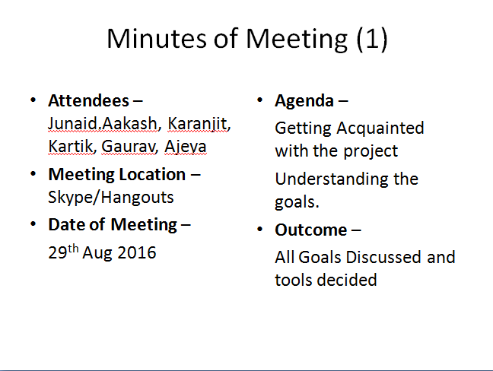**

**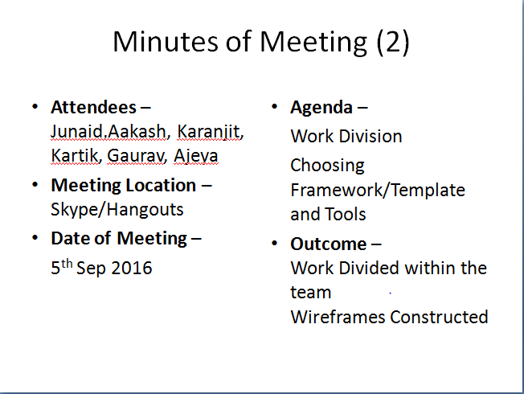**

**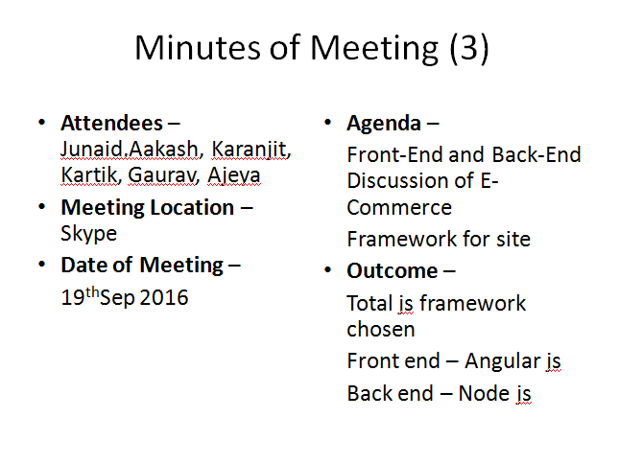**

**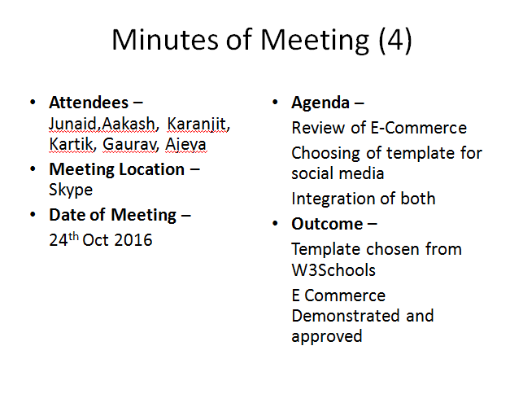**

**1.** **Informal Conversation (Facebook) –**

* Conversation started August 27
* [Junaid Maniyoor](https://www.facebook.com/junaidkhadisiya)

https://www.facebook.com/rsrc.php/v3/y4/r/-PAXP-deijE.gif8/27, 1:04pm

[**Junaid Maniyoor**](https://www.facebook.com/junaidkhadisiya)

Hi this is regarding your post on startup talky

we are looking for an app developed in android

can you do?

* https://www.facebook.com/rsrc.php/v3/y4/r/-PAXP-deijE.gif

Aug 27You accepted Junaid's request.

* [Aakash Sinha](https://www.facebook.com/aakash.sinha.001)

[https://www.facebook.com/rsrc.php/v3/y4/r/-PAXP-deijE.gif](https://www.facebook.com/mobile/messenger)8/27, 1:10pm

[**Aakash Sinha**](https://www.facebook.com/aakash.sinha.001)

Can you help me with the description or type of app you are looking for

* [Junaid Maniyoor](https://www.facebook.com/junaidkhadisiya)

https://www.facebook.com/rsrc.php/v3/y4/r/-PAXP-deijE.gif8/27, 1:23pm

[**Junaid Maniyoor**](https://www.facebook.com/junaidkhadisiya)

there?

* [Aakash Sinha](https://www.facebook.com/aakash.sinha.001)

[https://www.facebook.com/rsrc.php/v3/y4/r/-PAXP-deijE.gif](https://www.facebook.com/mobile/messenger)8/27, 1:23pm

[**Aakash Sinha**](https://www.facebook.com/aakash.sinha.001)

Yes

So can you tell me about the app?

* [Junaid Maniyoor](https://www.facebook.com/junaidkhadisiya)

https://www.facebook.com/rsrc.php/v3/y4/r/-PAXP-deijE.gif8/27, 1:23pm

[**Junaid Maniyoor**](https://www.facebook.com/junaidkhadisiya)

actually our projecct is a big one

we are planning social commerce application

of course as you understoo, social network + ecommerce

* [Aakash Sinha](https://www.facebook.com/aakash.sinha.001)

[https://www.facebook.com/rsrc.php/v3/y4/r/-PAXP-deijE.gif](https://www.facebook.com/mobile/messenger)8/27, 1:24pm

[**Aakash Sinha**](https://www.facebook.com/aakash.sinha.001)

Yaa

* [Junaid Maniyoor](https://www.facebook.com/junaidkhadisiya)

https://www.facebook.com/rsrc.php/v3/y4/r/-PAXP-deijE.gif8/27, 1:24pm

[**Junaid Maniyoor**](https://www.facebook.com/junaidkhadisiya)

already analysed and approved by indian angel network

but we need to develop a demo or basic app with some customer tractions for further funding

* [Aakash Sinha](https://www.facebook.com/aakash.sinha.001)

[https://www.facebook.com/rsrc.php/v3/y4/r/-PAXP-deijE.gif](https://www.facebook.com/mobile/messenger)8/27, 1:26pm

[**Aakash Sinha**](https://www.facebook.com/aakash.sinha.001)

So basically it will be a payment portal app?

* [Junaid Maniyoor](https://www.facebook.com/junaidkhadisiya)

https://www.facebook.com/rsrc.php/v3/y4/r/-PAXP-deijE.gif8/27, 1:26pm

[**Junaid Maniyoor**](https://www.facebook.com/junaidkhadisiya)

there comes some sort of payment too

can you check an pp peepinhour on playstore

they are not woring now

but you can see their features there

* [Aakash Sinha](https://www.facebook.com/aakash.sinha.001)

[https://www.facebook.com/rsrc.php/v3/y4/r/-PAXP-deijE.gif](https://www.facebook.com/mobile/messenger)8/27, 1:27pm

[**Aakash Sinha**](https://www.facebook.com/aakash.sinha.001)

Okay

* [Junaid Maniyoor](https://www.facebook.com/junaidkhadisiya)

https://www.facebook.com/rsrc.php/v3/y4/r/-PAXP-deijE.gif8/27, 1:27pm

[**Junaid Maniyoor**](https://www.facebook.com/junaidkhadisiya)

no need to download, but just to understand what exactly we are planning

* [Aakash Sinha](https://www.facebook.com/aakash.sinha.001)

[https://www.facebook.com/rsrc.php/v3/y4/r/-PAXP-deijE.gif](https://www.facebook.com/mobile/messenger)8/27, 1:27pm

[**Aakash Sinha**](https://www.facebook.com/aakash.sinha.001)

Yaa I will see

* [Junaid Maniyoor](https://www.facebook.com/junaidkhadisiya)

https://www.facebook.com/rsrc.php/v3/y4/r/-PAXP-deijE.gif8/27, 1:28pm

[**Junaid Maniyoor**](https://www.facebook.com/junaidkhadisiya)

sorry peepinnow

* [Junaid Maniyoor](https://www.facebook.com/junaidkhadisiya)

https://www.facebook.com/rsrc.php/v3/y4/r/-PAXP-deijE.gif8/27, 1:28pm

[**Junaid Maniyoor**](https://www.facebook.com/junaidkhadisiya)

<https://play.google.com/store/apps/details?id=com.irinnovative.peepinnow&hl=en>

[[](http://l.facebook.com/l.php?u=http://play.google.com/store/apps/details?id=com.irinnovative.peepinnow&h=ZAQFQrzMu&enc=AZNs9a9wVVJ1VesubO-eW5Dn-EjAaKqKcRk1V9qbvKT3WhgLEnjunF1x-GKSgFs7JRX33-rlGpl28W1GBlByhBVoGngXyAPdgZtrWMRKg98UiLRAbaks16KeVmcTflL1lvY&s=1)](http://l.facebook.com/l.php?u=http%3A%2F%2Fplay.google.com%2Fstore%2Fapps%2Fdetails%3Fid%3Dcom.irinnovative.peepinnow&h=ZAQFQrzMu&enc=AZNs9a9wVVJ1VesubO-eW5Dn-EjAaKqKcRk1V9qbvKT3WhgLEnjunF1x-GKSgFs7JRX33-rlGpl28W1GBlByhBVoGngXyAPdgZtrWMRKg98UiLRAbaks16KeVmcTflL1lvY&s=1" \t "_blank)

**[peepinNOW](http://l.facebook.com/l.php?u=http%3A%2F%2Fplay.google.com%2Fstore%2Fapps%2Fdetails%3Fid%3Dcom.irinnovative.peepinnow&h=ZAQFQrzMu&enc=AZNs9a9wVVJ1VesubO-eW5Dn-EjAaKqKcRk1V9qbvKT3WhgLEnjunF1x-GKSgFs7JRX33-rlGpl28W1GBlByhBVoGngXyAPdgZtrWMRKg98UiLRAbaks16KeVmcTflL1lvY&s=1" \t "_blank)**

[Get it on Google Play](http://l.facebook.com/l.php?u=http%3A%2F%2Fplay.google.com%2Fstore%2Fapps%2Fdetails%3Fid%3Dcom.irinnovative.peepinnow&h=ZAQFQrzMu&enc=AZNs9a9wVVJ1VesubO-eW5Dn-EjAaKqKcRk1V9qbvKT3WhgLEnjunF1x-GKSgFs7JRX33-rlGpl28W1GBlByhBVoGngXyAPdgZtrWMRKg98UiLRAbaks16KeVmcTflL1lvY&s=1" \t "_blank)

* [Aakash Sinha](https://www.facebook.com/aakash.sinha.001)

[https://www.facebook.com/rsrc.php/v3/y4/r/-PAXP-deijE.gif](https://www.facebook.com/mobile/messenger)8/27, 1:28pm

[**Aakash Sinha**](https://www.facebook.com/aakash.sinha.001)

Yaa thats why it wasn't showing

Okay I looked into it

It's a good idea

Is this idea already existing?

* [Junaid Maniyoor](https://www.facebook.com/junaidkhadisiya)

https://www.facebook.com/rsrc.php/v3/y4/r/-PAXP-deijE.gif8/27, 1:31pm

[**Junaid Maniyoor**](https://www.facebook.com/junaidkhadisiya)

yeah

there are so many

but i dont know in indian market

* [Aakash Sinha](https://www.facebook.com/aakash.sinha.001)

[https://www.facebook.com/rsrc.php/v3/y4/r/-PAXP-deijE.gif](https://www.facebook.com/mobile/messenger)8/27, 1:32pm

[**Aakash Sinha**](https://www.facebook.com/aakash.sinha.001)

Okay

I will tell you by tomorrow

I will have to discuss with my team

Is there any other challenging idea for an app, you can tell me

* [Junaid Maniyoor](https://www.facebook.com/junaidkhadisiya)

https://www.facebook.com/rsrc.php/v3/y4/r/-PAXP-deijE.gif8/27, 1:34pm

[**Junaid Maniyoor**](https://www.facebook.com/junaidkhadisiya)

ok, good

of course, there will be more challenging on the same app

as we are planning some exclusive features

discussion is going on with some investors and developers

but by the time we need to develop a basic app and to attract some customers

* [Aakash Sinha](https://www.facebook.com/aakash.sinha.001)

[https://www.facebook.com/rsrc.php/v3/y4/r/-PAXP-deijE.gif](https://www.facebook.com/mobile/messenger)8/27, 1:35pm

[**Aakash Sinha**](https://www.facebook.com/aakash.sinha.001)

Yaa cool

I get it

* [Junaid Maniyoor](https://www.facebook.com/junaidkhadisiya)

https://www.facebook.com/rsrc.php/v3/y4/r/-PAXP-deijE.gif8/27, 1:35pm

[**Junaid Maniyoor**](https://www.facebook.com/junaidkhadisiya)

let me know more about u

* [Aakash Sinha](https://www.facebook.com/aakash.sinha.001)

[https://www.facebook.com/rsrc.php/v3/y4/r/-PAXP-deijE.gif](https://www.facebook.com/mobile/messenger)8/27, 1:37pm

[**Aakash Sinha**](https://www.facebook.com/aakash.sinha.001)

I am currently doing my under graduation 3rd year in cse and am good at programming and web development. I am having a good team of programmers

* [Junaid Maniyoor](https://www.facebook.com/junaidkhadisiya)

https://www.facebook.com/rsrc.php/v3/y4/r/-PAXP-deijE.gif8/27, 1:37pm

[**Junaid Maniyoor**](https://www.facebook.com/junaidkhadisiya)

good

where are you from

which technoloies

* [Aakash Sinha](https://www.facebook.com/aakash.sinha.001)

[https://www.facebook.com/rsrc.php/v3/y4/r/-PAXP-deijE.gif](https://www.facebook.com/mobile/messenger)8/27, 1:37pm

[**Aakash Sinha**](https://www.facebook.com/aakash.sinha.001)

I am from Jamshedpur

Have done a project in meteor js

* [Junaid Maniyoor](https://www.facebook.com/junaidkhadisiya)

https://www.facebook.com/rsrc.php/v3/y4/r/-PAXP-deijE.gif8/27, 1:38pm

[**Junaid Maniyoor**](https://www.facebook.com/junaidkhadisiya)

okey

any prior experience in android?

* [Aakash Sinha](https://www.facebook.com/aakash.sinha.001)

[https://www.facebook.com/rsrc.php/v3/y4/r/-PAXP-deijE.gif](https://www.facebook.com/mobile/messenger)8/27, 1:38pm

[**Aakash Sinha**](https://www.facebook.com/aakash.sinha.001)

Multi platform app development

* [Junaid Maniyoor](https://www.facebook.com/junaidkhadisiya)

https://www.facebook.com/rsrc.php/v3/y4/r/-PAXP-deijE.gif8/27, 1:39pm

[**Junaid Maniyoor**](https://www.facebook.com/junaidkhadisiya)

which technology

* [Aakash Sinha](https://www.facebook.com/aakash.sinha.001)

[https://www.facebook.com/rsrc.php/v3/y4/r/-PAXP-deijE.gif](https://www.facebook.com/mobile/messenger)8/27, 1:40pm

[**Aakash Sinha**](https://www.facebook.com/aakash.sinha.001)

Angular js

* [Junaid Maniyoor](https://www.facebook.com/junaidkhadisiya)

https://www.facebook.com/rsrc.php/v3/y4/r/-PAXP-deijE.gif8/27, 1:40pm

[**Junaid Maniyoor**](https://www.facebook.com/junaidkhadisiya)

ok

so are you confident on this peepinnow?

* [Aakash Sinha](https://www.facebook.com/aakash.sinha.001)

[https://www.facebook.com/rsrc.php/v3/y4/r/-PAXP-deijE.gif](https://www.facebook.com/mobile/messenger)8/27, 1:41pm

[**Aakash Sinha**](https://www.facebook.com/aakash.sinha.001)

It looks good

Will discuss with my team once

And then get back to you

* [Junaid Maniyoor](https://www.facebook.com/junaidkhadisiya)

https://www.facebook.com/rsrc.php/v3/y4/r/-PAXP-deijE.gif8/27, 1:42pm

[**Junaid Maniyoor**](https://www.facebook.com/junaidkhadisiya)

okey

do you got any other ideas too?

is it only for project ?

* [Junaid Maniyoor](https://www.facebook.com/junaidkhadisiya)

https://www.facebook.com/rsrc.php/v3/y4/r/-PAXP-deijE.gif8/27, 1:51pm

[**Junaid Maniyoor**](https://www.facebook.com/junaidkhadisiya)

are you there?

* [Aakash Sinha](https://www.facebook.com/aakash.sinha.001)

[https://www.facebook.com/rsrc.php/v3/y4/r/-PAXP-deijE.gif](https://www.facebook.com/mobile/messenger)8/27, 1:53pm

[**Aakash Sinha**](https://www.facebook.com/aakash.sinha.001)

See this is a part of our project but this is surely for real life consumers, so if we are working on your idea then after completing it, we will hand it over to you

So are you willing to pay or do you just want a free basic app

* [Junaid Maniyoor](https://www.facebook.com/junaidkhadisiya)

https://www.facebook.com/rsrc.php/v3/y4/r/-PAXP-deijE.gif8/27, 1:54pm

[**Junaid Maniyoor**](https://www.facebook.com/junaidkhadisiya)

that's why i am asking

if you can satisfy us with what exactly we need, of course we want to pay something

* [Aakash Sinha](https://www.facebook.com/aakash.sinha.001)

[https://www.facebook.com/rsrc.php/v3/y4/r/-PAXP-deijE.gif](https://www.facebook.com/mobile/messenger)8/27, 1:55pm

[**Aakash Sinha**](https://www.facebook.com/aakash.sinha.001)

This is purely a professional work that's why I was asking

Please give a detailed description of your requirement from the app

Just think over it. Be as elaborate as you can. My team members are interested in the idea and think we can deliver it so take your time and give me the detailed requirement specifications and we will be happy to work

* [Junaid Maniyoor](https://www.facebook.com/junaidkhadisiya)

https://www.facebook.com/rsrc.php/v3/y4/r/-PAXP-deijE.gif8/27, 1:58pm

[**Junaid Maniyoor**](https://www.facebook.com/junaidkhadisiya)

ok sure

also let me know the financial expectations too

we need exactly the same app peepinnow

may be in future there will be some more features

but not now

* [Aakash Sinha](https://www.facebook.com/aakash.sinha.001)

[https://www.facebook.com/rsrc.php/v3/y4/r/-PAXP-deijE.gif](https://www.facebook.com/mobile/messenger)8/27, 2:01pm

[**Aakash Sinha**](https://www.facebook.com/aakash.sinha.001)

We'll let you know as soon as you provide us with the specifications.

* [Junaid Maniyoor](https://www.facebook.com/junaidkhadisiya)

https://www.facebook.com/rsrc.php/v3/y4/r/-PAXP-deijE.gif8/27, 2:02pm

[**Junaid Maniyoor**](https://www.facebook.com/junaidkhadisiya)

ok, we are in discussion with other developers too. so if it is affordable we will work with u

* [Aakash Sinha](https://www.facebook.com/aakash.sinha.001)

[https://www.facebook.com/rsrc.php/v3/y4/r/-PAXP-deijE.gif](https://www.facebook.com/mobile/messenger)8/27, 2:04pm

[**Aakash Sinha**](https://www.facebook.com/aakash.sinha.001)

Yaa sure

* [Junaid Maniyoor](https://www.facebook.com/junaidkhadisiya)

https://www.facebook.com/rsrc.php/v3/y4/r/-PAXP-deijE.gif8/27, 2:08pm

[**Junaid Maniyoor**](https://www.facebook.com/junaidkhadisiya)

ok pls share ur mail id

i will send features today or by tomorrow mring

* [Aakash Sinha](https://www.facebook.com/aakash.sinha.001)

[https://www.facebook.com/rsrc.php/v3/y4/r/-PAXP-deijE.gif](https://www.facebook.com/mobile/messenger)8/27, 2:08pm

[**Aakash Sinha**](https://www.facebook.com/aakash.sinha.001)

aakash19developer@gmail.com

Yaa sure

* [Junaid Maniyoor](https://www.facebook.com/junaidkhadisiya)

https://www.facebook.com/rsrc.php/v3/y4/r/-PAXP-deijE.gif8/27, 5:01pm

[**Junaid Maniyoor**](https://www.facebook.com/junaidkhadisiya)

just mailed

* [Aakash Sinha](https://www.facebook.com/aakash.sinha.001)

[https://www.facebook.com/rsrc.php/v3/y4/r/-PAXP-deijE.gif](https://www.facebook.com/mobile/messenger)8/27, 5:15pm

[**Aakash Sinha**](https://www.facebook.com/aakash.sinha.001)

Recieved

Will go through it

* [Junaid Maniyoor](https://www.facebook.com/junaidkhadisiya)

https://www.facebook.com/rsrc.php/v3/y4/r/-PAXP-deijE.gif8/27, 5:15pm

[**Junaid Maniyoor**](https://www.facebook.com/junaidkhadisiya)

ok, if you have any doubt let me know

* [Aakash Sinha](https://www.facebook.com/aakash.sinha.001)

[https://www.facebook.com/rsrc.php/v3/y4/r/-PAXP-deijE.gif](https://www.facebook.com/mobile/messenger)8/27, 5:15pm

[**Aakash Sinha**](https://www.facebook.com/aakash.sinha.001)

Sure

* [Junaid Maniyoor](https://www.facebook.com/junaidkhadisiya)

https://www.facebook.com/rsrc.php/v3/y4/r/-PAXP-deijE.gif8/27, 5:16pm

[**Junaid Maniyoor**](https://www.facebook.com/junaidkhadisiya)

it's the basic features. you can refer both links

so that you wil get more ideas

* [Aakash Sinha](https://www.facebook.com/aakash.sinha.001)

[https://www.facebook.com/rsrc.php/v3/y4/r/-PAXP-deijE.gif](https://www.facebook.com/mobile/messenger)8/27, 5:16pm

[**Aakash Sinha**](https://www.facebook.com/aakash.sinha.001)

Yaa got it

* August 28
* [Aakash Sinha](https://www.facebook.com/aakash.sinha.001)

[https://www.facebook.com/rsrc.php/v3/y4/r/-PAXP-deijE.gif](https://www.facebook.com/mobile/messenger)8/28, 12:16am

[**Aakash Sinha**](https://www.facebook.com/aakash.sinha.001)

We will do it

I have confirmed with my team

We can do it

* August 28
* [Junaid Maniyoor](https://www.facebook.com/junaidkhadisiya)

[https://www.facebook.com/rsrc.php/v3/y4/r/-PAXP-deijE.gif](https://www.facebook.com/mobile/)8/28, 11:39am

[**Junaid Maniyoor**](https://www.facebook.com/junaidkhadisiya)

Good

Give me more details

* [Aakash Sinha](https://www.facebook.com/aakash.sinha.001)

https://www.facebook.com/rsrc.php/v3/y4/r/-PAXP-deijE.gif8/28, 1:27pm

[**Aakash Sinha**](https://www.facebook.com/aakash.sinha.001)

We believe you want an android app

\*want

* [Junaid Maniyoor](https://www.facebook.com/junaidkhadisiya)

[https://www.facebook.com/rsrc.php/v3/y4/r/-PAXP-deijE.gif](https://www.facebook.com/mobile/)8/28, 1:45pm

[**Junaid Maniyoor**](https://www.facebook.com/junaidkhadisiya)

Yes

App and website

Priority is for app

* [Aakash Sinha](https://www.facebook.com/aakash.sinha.001)

https://www.facebook.com/rsrc.php/v3/y4/r/-PAXP-deijE.gif8/28, 1:47pm

[**Aakash Sinha**](https://www.facebook.com/aakash.sinha.001)

My team is more skilled at web dev

but if you want the app we can port a web app for the android platform

* [Junaid Maniyoor](https://www.facebook.com/junaidkhadisiya)

[https://www.facebook.com/rsrc.php/v3/y4/r/-PAXP-deijE.gif](https://www.facebook.com/mobile/)8/28, 1:48pm

[**Junaid Maniyoor**](https://www.facebook.com/junaidkhadisiya)

I dont have more knowledege in android

Si if u port can we use it as seperate mobile app? Can we publish it on google playstore?

* [Aakash Sinha](https://www.facebook.com/aakash.sinha.001)

https://www.facebook.com/rsrc.php/v3/y4/r/-PAXP-deijE.gif8/28, 1:51pm

[**Aakash Sinha**](https://www.facebook.com/aakash.sinha.001)

yes

an apk will be generated which can be uploaded to the play store

* [Junaid Maniyoor](https://www.facebook.com/junaidkhadisiya)

[https://www.facebook.com/rsrc.php/v3/y4/r/-PAXP-deijE.gif](https://www.facebook.com/mobile/)8/28, 1:52pm

[**Junaid Maniyoor**](https://www.facebook.com/junaidkhadisiya)

Ok

Good

So users can dowmload the app from playstore and use it

* [Aakash Sinha](https://www.facebook.com/aakash.sinha.001)

https://www.facebook.com/rsrc.php/v3/y4/r/-PAXP-deijE.gif8/28, 1:53pm

[**Aakash Sinha**](https://www.facebook.com/aakash.sinha.001)

yes

* [Junaid Maniyoor](https://www.facebook.com/junaidkhadisiya)

[https://www.facebook.com/rsrc.php/v3/y4/r/-PAXP-deijE.gif](https://www.facebook.com/mobile/)8/28, 1:53pm

[**Junaid Maniyoor**](https://www.facebook.com/junaidkhadisiya)

Right?

Same time we can use the same website with same funtiinality in desktop too

* [Aakash Sinha](https://www.facebook.com/aakash.sinha.001)

https://www.facebook.com/rsrc.php/v3/y4/r/-PAXP-deijE.gif8/28, 1:54pm

[**Aakash Sinha**](https://www.facebook.com/aakash.sinha.001)

yes

* [Junaid Maniyoor](https://www.facebook.com/junaidkhadisiya)

[https://www.facebook.com/rsrc.php/v3/y4/r/-PAXP-deijE.gif](https://www.facebook.com/mobile/)8/28, 1:55pm

[**Junaid Maniyoor**](https://www.facebook.com/junaidkhadisiya)

Thats cool

Are u confident?

* [Aakash Sinha](https://www.facebook.com/aakash.sinha.001)

https://www.facebook.com/rsrc.php/v3/y4/r/-PAXP-deijE.gif8/28, 1:56pm

[**Aakash Sinha**](https://www.facebook.com/aakash.sinha.001)

Yes, we have the skill set and time to complete the project

no reason to not be confident

We would like you to send your expectations and we'll start as soon as our objectives are clear

* [Junaid Maniyoor](https://www.facebook.com/junaidkhadisiya)

[https://www.facebook.com/rsrc.php/v3/y4/r/-PAXP-deijE.gif](https://www.facebook.com/mobile/)8/28, 2:00pm

[**Junaid Maniyoor**](https://www.facebook.com/junaidkhadisiya)

Ok

How much time it will take

* [Aakash Sinha](https://www.facebook.com/aakash.sinha.001)

[https://www.facebook.com/rsrc.php/v3/y4/r/-PAXP-deijE.gif](https://www.facebook.com/mobile/messenger)8/28, 2:11pm

[**Aakash Sinha**](https://www.facebook.com/aakash.sinha.001)

The basic app can be made in 1 month and the final product can be made within 2-3 months depending on the added features

* [Junaid Maniyoor](https://www.facebook.com/junaidkhadisiya)

[https://www.facebook.com/rsrc.php/v3/y4/r/-PAXP-deijE.gif](https://www.facebook.com/mobile/)8/28, 2:14pm

[**Junaid Maniyoor**](https://www.facebook.com/junaidkhadisiya)

Okey good

So whata next step?

* [Aakash Sinha](https://www.facebook.com/aakash.sinha.001)

[https://www.facebook.com/rsrc.php/v3/y4/r/-PAXP-deijE.gif](https://www.facebook.com/mobile/messenger)8/28, 2:33pm

[**Aakash Sinha**](https://www.facebook.com/aakash.sinha.001)

How much are you willing to pay for the final product?

Next step is obviously we will starting with the basic layout of the app

* [Junaid Maniyoor](https://www.facebook.com/junaidkhadisiya)

[https://www.facebook.com/rsrc.php/v3/y4/r/-PAXP-deijE.gif](https://www.facebook.com/mobile/)8/28, 2:37pm

[**Junaid Maniyoor**](https://www.facebook.com/junaidkhadisiya)

Have u got the actual concept?

* [Aakash Sinha](https://www.facebook.com/aakash.sinha.001)

[https://www.facebook.com/rsrc.php/v3/y4/r/-PAXP-deijE.gif](https://www.facebook.com/mobile/messenger)8/28, 2:37pm

[**Aakash Sinha**](https://www.facebook.com/aakash.sinha.001)

Yaa

* [Junaid Maniyoor](https://www.facebook.com/junaidkhadisiya)

[https://www.facebook.com/rsrc.php/v3/y4/r/-PAXP-deijE.gif](https://www.facebook.com/mobile/)8/28, 2:37pm

[**Junaid Maniyoor**](https://www.facebook.com/junaidkhadisiya)

We need an android app and a responsive website exactly as on socialengine

With ecommerce and chat dacility

Facility

There are more other features too. Like list classifieds Events, news etc.

Pla check socilaengine link thoroughly

U will get clear idea

* [Aakash Sinha](https://www.facebook.com/aakash.sinha.001)

[https://www.facebook.com/rsrc.php/v3/y4/r/-PAXP-deijE.gif](https://www.facebook.com/mobile/messenger)8/28, 2:39pm

[**Aakash Sinha**](https://www.facebook.com/aakash.sinha.001)

We did

Do you want us to work on the app or the website

* [Junaid Maniyoor](https://www.facebook.com/junaidkhadisiya)

[https://www.facebook.com/rsrc.php/v3/y4/r/-PAXP-deijE.gif](https://www.facebook.com/mobile/)8/28, 2:41pm

[**Junaid Maniyoor**](https://www.facebook.com/junaidkhadisiya)

Both

We need both

Because we are targeting both customers

in Next phase we need app in iOS too

* [Aakash Sinha](https://www.facebook.com/aakash.sinha.001)

[https://www.facebook.com/rsrc.php/v3/y4/r/-PAXP-deijE.gif](https://www.facebook.com/mobile/messenger)8/28, 2:43pm

[**Aakash Sinha**](https://www.facebook.com/aakash.sinha.001)

Building a responsive website is one thing building a cross platform web app is another

We can either make a web app for cross platform, user can open the website on all devices or a just responsive website( not meant to be ported)

I recommend that we get started on the website first, so that you have a site to use.

Then target mobile platform with the cross platform apps

* [Junaid Maniyoor](https://www.facebook.com/junaidkhadisiya)

[https://www.facebook.com/rsrc.php/v3/y4/r/-PAXP-deijE.gif](https://www.facebook.com/mobile/)8/28, 3:50pm

[**Junaid Maniyoor**](https://www.facebook.com/junaidkhadisiya)

Ok

Let me know ur expectations too for final product

* [Aakash Sinha](https://www.facebook.com/aakash.sinha.001)

8/28, 3:52pm

[**Aakash Sinha**](https://www.facebook.com/aakash.sinha.001)

yaa

* [Junaid Maniyoor](https://www.facebook.com/junaidkhadisiya)

[https://www.facebook.com/rsrc.php/v3/y4/r/-PAXP-deijE.gif](https://www.facebook.com/mobile/)8/28, 3:58pm

[**Junaid Maniyoor**](https://www.facebook.com/junaidkhadisiya)

Please make a detailed quote which will explain what u will do for us. The features, funtionalities etc. All based on socialengine lunk which i provide. We need well functioning social commerce Website

I mean just a copy of socialengine

Pls thorougly go through and play with it. Then only u will get clear picture and u can make clear documentation. I think u already logged in and understood all functionalities. They used magento for ecommerce part

* [Aakash Sinha](https://www.facebook.com/aakash.sinha.001)

https://www.facebook.com/rsrc.php/v3/y4/r/-PAXP-deijE.gif8/28, 4:12pm

[**Aakash Sinha**](https://www.facebook.com/aakash.sinha.001)

yaa sure

* August 28
* [Aakash Sinha](https://www.facebook.com/aakash.sinha.001)

8/28, 10:54pm

[**Aakash Sinha**](https://www.facebook.com/aakash.sinha.001)

we will send you a detailed quote by tomorrow

* August 29
* [Aakash Sinha](https://www.facebook.com/aakash.sinha.001)

https://www.facebook.com/rsrc.php/v3/y4/r/-PAXP-deijE.gif8/29, 8:52pm

[**Aakash Sinha**](https://www.facebook.com/aakash.sinha.001)

can i get your contact no.

i will share the detailed information of our workk in 2 hrs

* [Aakash Sinha](https://www.facebook.com/aakash.sinha.001)

https://www.facebook.com/rsrc.php/v3/y4/r/-PAXP-deijE.gif8/29, 9:14pm

[**Aakash Sinha**](https://www.facebook.com/aakash.sinha.001)

we understood the concept of peen in now and we an make a similar website but if you have some design or layout then you can send that to us

* https://www.facebook.com/rsrc.php/v3/y4/r/-PAXP-deijE.gif

Aug 29You set the nickname for Junaid Maniyoor to 1.5 Lakhs.

* https://www.facebook.com/rsrc.php/v3/y4/r/-PAXP-deijE.gif

Aug 29You cleared the nickname for Junaid Maniyoor.

* [Aakash Sinha](https://www.facebook.com/aakash.sinha.001)

https://www.facebook.com/rsrc.php/v3/y4/r/-PAXP-deijE.gif8/29, 9:25pm

[**Aakash Sinha**](https://www.facebook.com/aakash.sinha.001)

there?

* [Aakash Sinha](https://www.facebook.com/aakash.sinha.001)

https://www.facebook.com/rsrc.php/v3/y4/r/-PAXP-deijE.gif8/29, 9:34pm

[**Aakash Sinha**](https://www.facebook.com/aakash.sinha.001)

so our team consists of 5 people

2 will be dedicated for front end, 2 for back end and 1 for documentation

we have decided the team roles as per the potential of each person

* [Aakash Sinha](https://www.facebook.com/aakash.sinha.001)

https://www.facebook.com/rsrc.php/v3/y4/r/-PAXP-deijE.gif8/29, 9:51pm

[**Aakash Sinha**](https://www.facebook.com/aakash.sinha.001)

we will start by deciding a template as the basic design of the website. If you want any particular interface or design you can share with us

* [Aakash Sinha](https://www.facebook.com/aakash.sinha.001)

https://www.facebook.com/rsrc.php/v3/y4/r/-PAXP-deijE.gif8/29, 11:04pm

[**Aakash Sinha**](https://www.facebook.com/aakash.sinha.001)

then we will start with the responsive web design with angular js framework and we will be doing back end on mongo db

there?

* August 30
* [Aakash Sinha](https://www.facebook.com/aakash.sinha.001)

[https://www.facebook.com/rsrc.php/v3/y4/r/-PAXP-deijE.gif](https://www.facebook.com/mobile/messenger)8/30, 3:44am

[**Aakash Sinha**](https://www.facebook.com/aakash.sinha.001)

We will appreciate your acknowledgement for starting the work :)

Our team is ready to start the work as soon as possible. Waiting for your response.

* August 30
* [Junaid Maniyoor](https://www.facebook.com/junaidkhadisiya)

[https://www.facebook.com/rsrc.php/v3/y4/r/-PAXP-deijE.gif](https://www.facebook.com/mobile/)8/30, 10:53am

[**Junaid Maniyoor**](https://www.facebook.com/junaidkhadisiya)

Ok

Have u send the details?

* [Aakash Sinha](https://www.facebook.com/aakash.sinha.001)

[https://www.facebook.com/rsrc.php/v3/y4/r/-PAXP-deijE.gif](https://www.facebook.com/mobile/messenger)8/30, 11:26am

[**Aakash Sinha**](https://www.facebook.com/aakash.sinha.001)

We sent you a message yesterday

But if you want a formal email we will send you one by 6 pm today

* [Junaid Maniyoor](https://www.facebook.com/junaidkhadisiya)

https://www.facebook.com/rsrc.php/v3/y4/r/-PAXP-deijE.gif8/30, 11:28am

[**Junaid Maniyoor**](https://www.facebook.com/junaidkhadisiya)

ok, pls send it to mail id

so that i can share and discuss with my collegues too

* [Aakash Sinha](https://www.facebook.com/aakash.sinha.001)

[https://www.facebook.com/rsrc.php/v3/y4/r/-PAXP-deijE.gif](https://www.facebook.com/mobile/messenger)8/30, 11:29am

[**Aakash Sinha**](https://www.facebook.com/aakash.sinha.001)

Yaa sure

* August 30
* [Aakash Sinha](https://www.facebook.com/aakash.sinha.001)

https://www.facebook.com/rsrc.php/v3/y4/r/-PAXP-deijE.gif8/30, 5:57pm

[**Aakash Sinha**](https://www.facebook.com/aakash.sinha.001)

i have sent you th mail

i have sent you two mails

kindly go through them and respond soon

after getting your confirmation we would start right away

:)

* [Aakash Sinha](https://www.facebook.com/aakash.sinha.001)

https://www.facebook.com/rsrc.php/v3/y4/r/-PAXP-deijE.gif8/30, 6:07pm

[**Aakash Sinha**](https://www.facebook.com/aakash.sinha.001)

sorry for the delay in mail coz there was wifi shutdown in the campus yesterday evening so could not send the maul

mail

* [Aakash Sinha](https://www.facebook.com/aakash.sinha.001)

https://www.facebook.com/rsrc.php/v3/y4/r/-PAXP-deijE.gif8/30, 6:33pm

[**Aakash Sinha**](https://www.facebook.com/aakash.sinha.001)

waiting for your response

* August 30
* [Aakash Sinha](https://www.facebook.com/aakash.sinha.001)

[https://www.facebook.com/rsrc.php/v3/y4/r/-PAXP-deijE.gif](https://www.facebook.com/mobile/messenger)8/30, 10:04pm

[**Aakash Sinha**](https://www.facebook.com/aakash.sinha.001)

There?

* August 31
* [Junaid Maniyoor](https://www.facebook.com/junaidkhadisiya)

https://www.facebook.com/rsrc.php/v3/y4/r/-PAXP-deijE.gif8/31, 11:41am

[**Junaid Maniyoor**](https://www.facebook.com/junaidkhadisiya)

yes

* [Junaid Maniyoor](https://www.facebook.com/junaidkhadisiya)

https://www.facebook.com/rsrc.php/v3/y4/r/-PAXP-deijE.gif8/31, 12:08pm

[**Junaid Maniyoor**](https://www.facebook.com/junaidkhadisiya)

replied

pls check and revert me

* [Junaid Maniyoor](https://www.facebook.com/junaidkhadisiya)

https://www.facebook.com/rsrc.php/v3/y4/r/-PAXP-deijE.gif8/31, 12:08pm

[**Junaid Maniyoor**](https://www.facebook.com/junaidkhadisiya)

<http://socialcommerce.socialengineaddons.com/>

[[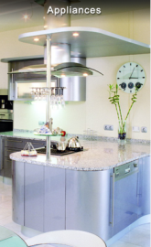](http://l.facebook.com/l.php?u=http://socialcommerce.socialengineaddons.com/&h=cAQFznJDH&s=1)](http://l.facebook.com/l.php?u=http%3A%2F%2Fsocialcommerce.socialengineaddons.com%2F&h=cAQFznJDH&s=1" \t "_blank)

**[SocialEngineAddOns - Home Page](http://l.facebook.com/l.php?u=http%3A%2F%2Fsocialcommerce.socialengineaddons.com%2F&h=cAQFznJDH&s=1" \t "_blank)**

[This is the demo site for showcasing the SocialEngine plugins created by SocialEngineAddOns for v4. This is the home page.](http://l.facebook.com/l.php?u=http%3A%2F%2Fsocialcommerce.socialengineaddons.com%2F&h=cAQFznJDH&s=1" \t "_blank)

[socialcommerce.socialengineaddons.com](http://l.facebook.com/l.php?u=http%3A%2F%2Fsocialcommerce.socialengineaddons.com%2F&h=cAQFznJDH&s=1" \t "_blank)

* [Junaid Maniyoor](https://www.facebook.com/junaidkhadisiya)

https://www.facebook.com/rsrc.php/v3/y4/r/-PAXP-deijE.gif8/31, 12:09pm

[**Junaid Maniyoor**](https://www.facebook.com/junaidkhadisiya)

this is the link of what we are looking for

pls sign in and send me the details

let me know ur expecting remunerations too. as you know, we are in discussion with some other developers too. of course will go with someone who is willing to make it on lower cost. even we are in discussion with another firm on equity share basis.

* August 31
* [Aakash Sinha](https://www.facebook.com/aakash.sinha.001)

https://www.facebook.com/rsrc.php/v3/y4/r/-PAXP-deijE.gif8/31, 4:00pm

[**Aakash Sinha**](https://www.facebook.com/aakash.sinha.001)

yaa i understand

* [Junaid Maniyoor](https://www.facebook.com/junaidkhadisiya)

https://www.facebook.com/rsrc.php/v3/y4/r/-PAXP-deijE.gif8/31, 4:02pm

[**Junaid Maniyoor**](https://www.facebook.com/junaidkhadisiya)

have u got the mail?

pls check and reply

* [Aakash Sinha](https://www.facebook.com/aakash.sinha.001)

https://www.facebook.com/rsrc.php/v3/y4/r/-PAXP-deijE.gif8/31, 4:02pm

[**Aakash Sinha**](https://www.facebook.com/aakash.sinha.001)

yaa i have got it

i am checking it

will reply by 6 pm

* [Junaid Maniyoor](https://www.facebook.com/junaidkhadisiya)

https://www.facebook.com/rsrc.php/v3/y4/r/-PAXP-deijE.gif8/31, 4:04pm

[**Junaid Maniyoor**](https://www.facebook.com/junaidkhadisiya)

ok

* [Aakash Sinha](https://www.facebook.com/aakash.sinha.001)

https://www.facebook.com/rsrc.php/v3/y4/r/-PAXP-deijE.gif8/31, 4:05pm

[**Aakash Sinha**](https://www.facebook.com/aakash.sinha.001)

can i know when will you be online

* [Junaid Maniyoor](https://www.facebook.com/junaidkhadisiya)

https://www.facebook.com/rsrc.php/v3/y4/r/-PAXP-deijE.gif8/31, 4:06pm

[**Junaid Maniyoor**](https://www.facebook.com/junaidkhadisiya)

till 6 i wil be in office

u just drop the messages

i wil check it anyway

* [Aakash Sinha](https://www.facebook.com/aakash.sinha.001)

https://www.facebook.com/rsrc.php/v3/y4/r/-PAXP-deijE.gif8/31, 4:06pm

[**Aakash Sinha**](https://www.facebook.com/aakash.sinha.001)

i will surely do it

* [Junaid Maniyoor](https://www.facebook.com/junaidkhadisiya)

https://www.facebook.com/rsrc.php/v3/y4/r/-PAXP-deijE.gif8/31, 4:07pm

[**Junaid Maniyoor**](https://www.facebook.com/junaidkhadisiya)

ok

* [Aakash Sinha](https://www.facebook.com/aakash.sinha.001)

https://www.facebook.com/rsrc.php/v3/y4/r/-PAXP-deijE.gif8/31, 4:10pm

[**Aakash Sinha**](https://www.facebook.com/aakash.sinha.001)

i am currently using the test accounts to access the website

* [Junaid Maniyoor](https://www.facebook.com/junaidkhadisiya)

https://www.facebook.com/rsrc.php/v3/y4/r/-PAXP-deijE.gif8/31, 4:11pm

[**Junaid Maniyoor**](https://www.facebook.com/junaidkhadisiya)

ok

* [Aakash Sinha](https://www.facebook.com/aakash.sinha.001)

https://www.facebook.com/rsrc.php/v3/y4/r/-PAXP-deijE.gif8/31, 4:14pm

[**Aakash Sinha**](https://www.facebook.com/aakash.sinha.001)

junaid can you tell us about the no. of team members you have

* [Junaid Maniyoor](https://www.facebook.com/junaidkhadisiya)

https://www.facebook.com/rsrc.php/v3/y4/r/-PAXP-deijE.gif8/31, 4:15pm

[**Junaid Maniyoor**](https://www.facebook.com/junaidkhadisiya)

we are 5

3 more people coming next weak

we are startup based in kannur

worked as freelancers , now just organized into a company

* [Aakash Sinha](https://www.facebook.com/aakash.sinha.001)

https://www.facebook.com/rsrc.php/v3/y4/r/-PAXP-deijE.gif8/31, 4:16pm

[**Aakash Sinha**](https://www.facebook.com/aakash.sinha.001)

what has your startup done till now?

* [Junaid Maniyoor](https://www.facebook.com/junaidkhadisiya)

https://www.facebook.com/rsrc.php/v3/y4/r/-PAXP-deijE.gif8/31, 4:17pm

[**Junaid Maniyoor**](https://www.facebook.com/junaidkhadisiya)

basically we are web/software company

now looking fo something new

that's why we are planning some products

social commerce, cab services, food and dining etc. based in kannur

* [Aakash Sinha](https://www.facebook.com/aakash.sinha.001)

https://www.facebook.com/rsrc.php/v3/y4/r/-PAXP-deijE.gif8/31, 4:20pm

[**Aakash Sinha**](https://www.facebook.com/aakash.sinha.001)

Is your company registered?

* [Junaid Maniyoor](https://www.facebook.com/junaidkhadisiya)

https://www.facebook.com/rsrc.php/v3/y4/r/-PAXP-deijE.gif8/31, 4:20pm

[**Junaid Maniyoor**](https://www.facebook.com/junaidkhadisiya)

corporation and kerala goverment licensed

private limited registration under process

* [Junaid Maniyoor](https://www.facebook.com/junaidkhadisiya)

https://www.facebook.com/rsrc.php/v3/y4/r/-PAXP-deijE.gif8/31, 4:21pm

[**Junaid Maniyoor**](https://www.facebook.com/junaidkhadisiya)

[www.safcodes.com](http://www.safcodes.com/) is our company website

[[](http://l.facebook.com/l.php?u=http://www.safcodes.com/&h=IAQGF5GXe&s=1)](http://l.facebook.com/l.php?u=http%3A%2F%2Fwww.safcodes.com%2F&h=IAQGF5GXe&s=1" \t "_blank)

**[Safcodes – Safcodes | Web and ecommerce solutions](http://l.facebook.com/l.php?u=http%3A%2F%2Fwww.safcodes.com%2F&h=IAQGF5GXe&s=1" \t "_blank)**

[Safcodes  Founded in 2012 is a full-service website development company based in Kannur, Kerala, India that specializes in custom Website Design, Website Development, e-Commerce Solutions, CMS Solutions, Search Engine Optimization (SEO),Database Management, Data Manipulation, Internet Marketing and…](http://l.facebook.com/l.php?u=http%3A%2F%2Fwww.safcodes.com%2F&h=IAQGF5GXe&s=1" \t "_blank)

[safcodes.com](http://l.facebook.com/l.php?u=http%3A%2F%2Fwww.safcodes.com%2F&h=IAQGF5GXe&s=1" \t "_blank)

* [Junaid Maniyoor](https://www.facebook.com/junaidkhadisiya)

https://www.facebook.com/rsrc.php/v3/y4/r/-PAXP-deijE.gif8/31, 4:21pm

[**Junaid Maniyoor**](https://www.facebook.com/junaidkhadisiya)

for the next product social commerce, we have new name Vaistreet

* [Junaid Maniyoor](https://www.facebook.com/junaidkhadisiya)

https://www.facebook.com/rsrc.php/v3/y4/r/-PAXP-deijE.gif8/31, 4:22pm

[**Junaid Maniyoor**](https://www.facebook.com/junaidkhadisiya)

[https://www.facebook.com/VaiStreet](https://www.facebook.com/VaiStreet?__mref=message)

[[](https://www.facebook.com/VaiStreet/)](https://www.facebook.com/VaiStreet/" \t "_blank)

**[VaiStreet](https://www.facebook.com/VaiStreet/" \t "_blank)**

[Something Awesome is on it's Way...](https://www.facebook.com/VaiStreet/" \t "_blank)

* [Junaid Maniyoor](https://www.facebook.com/junaidkhadisiya)

https://www.facebook.com/rsrc.php/v3/y4/r/-PAXP-deijE.gif8/31, 4:22pm

[**Junaid Maniyoor**](https://www.facebook.com/junaidkhadisiya)

is our social commerce product vaistreets page

* [Junaid Maniyoor](https://www.facebook.com/junaidkhadisiya)

https://www.facebook.com/rsrc.php/v3/y4/r/-PAXP-deijE.gif8/31, 4:22pm

[**Junaid Maniyoor**](https://www.facebook.com/junaidkhadisiya)

[www.vaistreet.com](http://www.vaistreet.com/)

[[](http://l.facebook.com/l.php?u=http://www.vaistreet.com/&h=9AQFbG_z-&s=1)](http://l.facebook.com/l.php?u=http%3A%2F%2Fwww.vaistreet.com%2F&h=9AQFbG_z-&s=1" \t "_blank)

**[Vaistreet.com - Coming Soon](http://l.facebook.com/l.php?u=http%3A%2F%2Fwww.vaistreet.com%2F&h=9AQFbG_z-&s=1" \t "_blank)**

[Lorem ipsum dolor sit amet, consectetur adipiscing elit. Cras vulputate arcu sit amet sem venenatis dictum. Vestibulum ante ipsum primis in faucibus orci luctus et ultrices posuere cubilia Curae; Suspendisse eu massa sed orci interdum lobortis. Vivamus rutrum.](http://l.facebook.com/l.php?u=http%3A%2F%2Fwww.vaistreet.com%2F&h=9AQFbG_z-&s=1" \t "_blank)

[vaistreet.com](http://l.facebook.com/l.php?u=http%3A%2F%2Fwww.vaistreet.com%2F&h=9AQFbG_z-&s=1" \t "_blank)

* [Aakash Sinha](https://www.facebook.com/aakash.sinha.001)

https://www.facebook.com/rsrc.php/v3/y4/r/-PAXP-deijE.gif8/31, 4:27pm

[**Aakash Sinha**](https://www.facebook.com/aakash.sinha.001)

Just to make sure that you were informed

this project will be part of our software course

therefore we require that your startup does not leave this project midway

we would need an evaluation from your side at the end of this

incentives are negotiable but we cannot lose a client midway

as far as the website requirements that you sent via email

we have the team to do the job, and since we are being evaluated there is no reason why we would not deliver what you want

please confirm

i'll be back in an hour

* [Junaid Maniyoor](https://www.facebook.com/junaidkhadisiya)

https://www.facebook.com/rsrc.php/v3/y4/r/-PAXP-deijE.gif8/31, 4:39pm

[**Junaid Maniyoor**](https://www.facebook.com/junaidkhadisiya)

ys understood

we are very serious into this project

we need to get it done asap at low cost

that's what we are aiming now

but i told you, we want to know your expectaions too

* [Junaid Maniyoor](https://www.facebook.com/junaidkhadisiya)

https://www.facebook.com/rsrc.php/v3/y4/r/-PAXP-deijE.gif8/31, 4:54pm

[**Junaid Maniyoor**](https://www.facebook.com/junaidkhadisiya)

sent another mail with word file attached

pls have a look into it. it describes the faces we need on this portal / mobile app

* [Aakash Sinha](https://www.facebook.com/aakash.sinha.001)

https://www.facebook.com/rsrc.php/v3/y4/r/-PAXP-deijE.gif8/31, 6:51pm

[**Aakash Sinha**](https://www.facebook.com/aakash.sinha.001)

we will send you our response by tonight and our coonfirmation as well

* [Aakash Sinha](https://www.facebook.com/aakash.sinha.001)

https://www.facebook.com/rsrc.php/v3/y4/r/-PAXP-deijE.gif8/31, 7:15pm

[**Aakash Sinha**](https://www.facebook.com/aakash.sinha.001)

we need to have a conversation to decide everything

can you tell me when can we have that

i am sending you the mail right now

* August 31
* [Junaid Maniyoor](https://www.facebook.com/junaidkhadisiya)

[https://www.facebook.com/rsrc.php/v3/y4/r/-PAXP-deijE.gif](https://www.facebook.com/mobile/)8/31, 11:21pm

[**Junaid Maniyoor**](https://www.facebook.com/junaidkhadisiya)

Ok

Xhecked it and forwarded to my colligues

Anyway we are ready

I want to, get confirmation from othera too

* [Aakash Sinha](https://www.facebook.com/aakash.sinha.001)

https://www.facebook.com/rsrc.php/v3/y4/r/-PAXP-deijE.gif8/31, 11:40pm

[**Aakash Sinha**](https://www.facebook.com/aakash.sinha.001)

yaa sure

tell us as soon as possible so that we can start

* September 1
* [Junaid Maniyoor](https://www.facebook.com/junaidkhadisiya)

https://www.facebook.com/rsrc.php/v3/y4/r/-PAXP-deijE.gif9/1, 12:52pm

[**Junaid Maniyoor**](https://www.facebook.com/junaidkhadisiya)

ok, will let you know by evening

* [Aakash Sinha](https://www.facebook.com/aakash.sinha.001)

[https://www.facebook.com/rsrc.php/v3/y4/r/-PAXP-deijE.gif](https://www.facebook.com/mobile/messenger)9/1, 12:53pm

[**Aakash Sinha**](https://www.facebook.com/aakash.sinha.001)

Yaa sure

* [Junaid Maniyoor](https://www.facebook.com/junaidkhadisiya)

https://www.facebook.com/rsrc.php/v3/y4/r/-PAXP-deijE.gif9/1, 12:53pm

[**Junaid Maniyoor**](https://www.facebook.com/junaidkhadisiya)

we are discussing about price only now. as i told i already got some proposals checking it and will let you soon

what are ur steps, i mean how we can start and close/

to start the project , what u need? when you will submit? do you need UI designs? will u design it too? and when you need the payment etc.

we already have server and domain

* [Aakash Sinha](https://www.facebook.com/aakash.sinha.001)

[https://www.facebook.com/rsrc.php/v3/y4/r/-PAXP-deijE.gif](https://www.facebook.com/mobile/messenger)9/1, 2:06pm

[**Aakash Sinha**](https://www.facebook.com/aakash.sinha.001)

If you want to give us a design, you can give us or you can give a basic UI and then we can modify it

We were to start the project last week but since we were in talk so could not start, but we had a group meeting yesterday and we will be starting the work from today itself

It's nice if you are having the server and domain so it won't be a problem for us

Regards the money, it is very negotiable. You can let us know whatever you are willing to pay because we are not freelancers and we won't be demanding any price.

* [Junaid Maniyoor](https://www.facebook.com/junaidkhadisiya)

https://www.facebook.com/rsrc.php/v3/y4/r/-PAXP-deijE.gif9/1, 2:16pm

[**Junaid Maniyoor**](https://www.facebook.com/junaidkhadisiya)

ok, good

if so you can start on it. i am getting some cheaper quotes too. that's why again and again i am stucking on price

have you checked that word file?

* [Aakash Sinha](https://www.facebook.com/aakash.sinha.001)

[https://www.facebook.com/rsrc.php/v3/y4/r/-PAXP-deijE.gif](https://www.facebook.com/mobile/messenger)9/1, 2:17pm

[**Aakash Sinha**](https://www.facebook.com/aakash.sinha.001)

Yaa

* [Junaid Maniyoor](https://www.facebook.com/junaidkhadisiya)

https://www.facebook.com/rsrc.php/v3/y4/r/-PAXP-deijE.gif9/1, 2:18pm

[**Junaid Maniyoor**](https://www.facebook.com/junaidkhadisiya)

gone through the link and logged in ?

* [Aakash Sinha](https://www.facebook.com/aakash.sinha.001)

[https://www.facebook.com/rsrc.php/v3/y4/r/-PAXP-deijE.gif](https://www.facebook.com/mobile/messenger)9/1, 2:18pm

[**Aakash Sinha**](https://www.facebook.com/aakash.sinha.001)

Yes done

* [Junaid Maniyoor](https://www.facebook.com/junaidkhadisiya)

https://www.facebook.com/rsrc.php/v3/y4/r/-PAXP-deijE.gif9/1, 2:18pm

[**Junaid Maniyoor**](https://www.facebook.com/junaidkhadisiya)

have you checked all minor featues?

* [Aakash Sinha](https://www.facebook.com/aakash.sinha.001)

[https://www.facebook.com/rsrc.php/v3/y4/r/-PAXP-deijE.gif](https://www.facebook.com/mobile/messenger)9/1, 2:18pm

[**Aakash Sinha**](https://www.facebook.com/aakash.sinha.001)

Understood the concept

* [Junaid Maniyoor](https://www.facebook.com/junaidkhadisiya)

https://www.facebook.com/rsrc.php/v3/y4/r/-PAXP-deijE.gif9/1, 2:18pm

[**Junaid Maniyoor**](https://www.facebook.com/junaidkhadisiya)

we need exactly the same as on that demo

* [Aakash Sinha](https://www.facebook.com/aakash.sinha.001)

[https://www.facebook.com/rsrc.php/v3/y4/r/-PAXP-deijE.gif](https://www.facebook.com/mobile/messenger)9/1, 2:18pm

[**Aakash Sinha**](https://www.facebook.com/aakash.sinha.001)

Yaa we get it

Can you tell me what is the cheapest quote you have received

Coz I want to finalise it with you today and don't want the money factor to be a stress at your part

* [Junaid Maniyoor](https://www.facebook.com/junaidkhadisiya)

https://www.facebook.com/rsrc.php/v3/y4/r/-PAXP-deijE.gif9/1, 2:22pm

[**Junaid Maniyoor**](https://www.facebook.com/junaidkhadisiya)

today morning i got a proposal from a freelancer from chennai , he is asking only 50,000 for both web and app with 6 months free support

portal for 25 k and android app for 25 k

checked it profile too. haveing 4 years experience

another quote is for 75k it's from a company from chennai itself

but you know i got a proposal of 3 lack also

* [Aakash Sinha](https://www.facebook.com/aakash.sinha.001)

[https://www.facebook.com/rsrc.php/v3/y4/r/-PAXP-deijE.gif](https://www.facebook.com/mobile/messenger)9/1, 2:24pm

[**Aakash Sinha**](https://www.facebook.com/aakash.sinha.001)

Oh

* [Junaid Maniyoor](https://www.facebook.com/junaidkhadisiya)

https://www.facebook.com/rsrc.php/v3/y4/r/-PAXP-deijE.gif9/1, 2:24pm

[**Junaid Maniyoor**](https://www.facebook.com/junaidkhadisiya)

that's why i am in confusion. i dont knw what you are expecting

* [Aakash Sinha](https://www.facebook.com/aakash.sinha.001)

[https://www.facebook.com/rsrc.php/v3/y4/r/-PAXP-deijE.gif](https://www.facebook.com/mobile/messenger)9/1, 2:24pm

[**Aakash Sinha**](https://www.facebook.com/aakash.sinha.001)

Hehe don't worry

We will do it lesser than the cheapest you have

20k for the website in 3 months

How about that?

* [Junaid Maniyoor](https://www.facebook.com/junaidkhadisiya)

https://www.facebook.com/rsrc.php/v3/y4/r/-PAXP-deijE.gif9/1, 2:27pm

[**Junaid Maniyoor**](https://www.facebook.com/junaidkhadisiya)

ok, what about mobile app

* [Aakash Sinha](https://www.facebook.com/aakash.sinha.001)

[https://www.facebook.com/rsrc.php/v3/y4/r/-PAXP-deijE.gif](https://www.facebook.com/mobile/messenger)9/1, 2:27pm

[**Aakash Sinha**](https://www.facebook.com/aakash.sinha.001)

You said you want the web portal first

That's why I told you regarding that

* [Junaid Maniyoor](https://www.facebook.com/junaidkhadisiya)

https://www.facebook.com/rsrc.php/v3/y4/r/-PAXP-deijE.gif9/1, 2:27pm

[**Junaid Maniyoor**](https://www.facebook.com/junaidkhadisiya)

yes, i need portal first

also need full source code

will u provide it?

* [Aakash Sinha](https://www.facebook.com/aakash.sinha.001)

[https://www.facebook.com/rsrc.php/v3/y4/r/-PAXP-deijE.gif](https://www.facebook.com/mobile/messenger)9/1, 2:28pm

[**Aakash Sinha**](https://www.facebook.com/aakash.sinha.001)

I will get back to you in 5 mins

Please stay online

* [Junaid Maniyoor](https://www.facebook.com/junaidkhadisiya)

https://www.facebook.com/rsrc.php/v3/y4/r/-PAXP-deijE.gif9/1, 2:28pm

[**Junaid Maniyoor**](https://www.facebook.com/junaidkhadisiya)

will be here

i am going for luch too

lunch

back sooon

* [Aakash Sinha](https://www.facebook.com/aakash.sinha.001)

[https://www.facebook.com/rsrc.php/v3/y4/r/-PAXP-deijE.gif](https://www.facebook.com/mobile/messenger)9/1, 2:28pm

[**Aakash Sinha**](https://www.facebook.com/aakash.sinha.001)

Fix a time

3 pm?

* [Junaid Maniyoor](https://www.facebook.com/junaidkhadisiya)

https://www.facebook.com/rsrc.php/v3/y4/r/-PAXP-deijE.gif9/1, 2:29pm

[**Junaid Maniyoor**](https://www.facebook.com/junaidkhadisiya)

yes

* [Aakash Sinha](https://www.facebook.com/aakash.sinha.001)

[https://www.facebook.com/rsrc.php/v3/y4/r/-PAXP-deijE.gif](https://www.facebook.com/mobile/messenger)9/1, 2:29pm

[**Aakash Sinha**](https://www.facebook.com/aakash.sinha.001)

Cool

I will be there

Please be online

* [Junaid Maniyoor](https://www.facebook.com/junaidkhadisiya)

https://www.facebook.com/rsrc.php/v3/y4/r/-PAXP-deijE.gif9/1, 2:29pm

[**Junaid Maniyoor**](https://www.facebook.com/junaidkhadisiya)

sure

* [Aakash Sinha](https://www.facebook.com/aakash.sinha.001)

9/1, 2:44pm

[**Aakash Sinha**](https://www.facebook.com/aakash.sinha.001)

yaa we will provide you with the full source code

I talked to my team members, we are 5 in number, can you do 30k, 3months, fully functional website with the source code?

there?

* [Junaid Maniyoor](https://www.facebook.com/junaidkhadisiya)

https://www.facebook.com/rsrc.php/v3/y4/r/-PAXP-deijE.gif9/1, 3:10pm

[**Junaid Maniyoor**](https://www.facebook.com/junaidkhadisiya)

but there is one proposed 25k already

can give 25k

* [Aakash Sinha](https://www.facebook.com/aakash.sinha.001)

https://www.facebook.com/rsrc.php/v3/y4/r/-PAXP-deijE.gif9/1, 3:11pm

[**Aakash Sinha**](https://www.facebook.com/aakash.sinha.001)

so 25 k shall be good?

were ok with 25

\*we are

* [Junaid Maniyoor](https://www.facebook.com/junaidkhadisiya)

https://www.facebook.com/rsrc.php/v3/y4/r/-PAXP-deijE.gif9/1, 3:13pm

[**Junaid Maniyoor**](https://www.facebook.com/junaidkhadisiya)

ok

but you need to submit a detailed proposal including what are the fucntionalities, features etc.

your time frame, cost, phases etc. must be covered

* [Aakash Sinha](https://www.facebook.com/aakash.sinha.001)

https://www.facebook.com/rsrc.php/v3/y4/r/-PAXP-deijE.gif9/1, 3:15pm

[**Aakash Sinha**](https://www.facebook.com/aakash.sinha.001)

yaa we have already decided to send you a mail regarding all the deatils by today

so dont worry about that

* [Junaid Maniyoor](https://www.facebook.com/junaidkhadisiya)

https://www.facebook.com/rsrc.php/v3/y4/r/-PAXP-deijE.gif9/1, 3:15pm

[**Junaid Maniyoor**](https://www.facebook.com/junaidkhadisiya)

need in a document

word or pdf

* [Aakash Sinha](https://www.facebook.com/aakash.sinha.001)

https://www.facebook.com/rsrc.php/v3/y4/r/-PAXP-deijE.gif9/1, 3:15pm

[**Aakash Sinha**](https://www.facebook.com/aakash.sinha.001)

yaa we will send you a word file

* [Junaid Maniyoor](https://www.facebook.com/junaidkhadisiya)

https://www.facebook.com/rsrc.php/v3/y4/r/-PAXP-deijE.gif9/1, 3:15pm

[**Junaid Maniyoor**](https://www.facebook.com/junaidkhadisiya)

with your full details

* [Aakash Sinha](https://www.facebook.com/aakash.sinha.001)

https://www.facebook.com/rsrc.php/v3/y4/r/-PAXP-deijE.gif9/1, 3:16pm

[**Aakash Sinha**](https://www.facebook.com/aakash.sinha.001)

yaa sure

* [Junaid Maniyoor](https://www.facebook.com/junaidkhadisiya)

https://www.facebook.com/rsrc.php/v3/y4/r/-PAXP-deijE.gif9/1, 3:16pm

[**Junaid Maniyoor**](https://www.facebook.com/junaidkhadisiya)

memebers, contacts etc.

* [Aakash Sinha](https://www.facebook.com/aakash.sinha.001)

https://www.facebook.com/rsrc.php/v3/y4/r/-PAXP-deijE.gif9/1, 3:16pm

[**Aakash Sinha**](https://www.facebook.com/aakash.sinha.001)

yaa

* [Junaid Maniyoor](https://www.facebook.com/junaidkhadisiya)

https://www.facebook.com/rsrc.php/v3/y4/r/-PAXP-deijE.gif9/1, 3:17pm

[**Junaid Maniyoor**](https://www.facebook.com/junaidkhadisiya)

we will study the document clearly. again i am telling we need the portal exactly as on <http://socialcommerce.socialengineaddons.com/>

what about mobile app?

can you do it after?

* [Aakash Sinha](https://www.facebook.com/aakash.sinha.001)

https://www.facebook.com/rsrc.php/v3/y4/r/-PAXP-deijE.gif9/1, 3:20pm

[**Aakash Sinha**](https://www.facebook.com/aakash.sinha.001)

we will finisih the web portal in 3 monts

then we can decide to make an app

i would suggest that if you outsource the app then you can have both ready in 3 monts

months\*

* [Junaid Maniyoor](https://www.facebook.com/junaidkhadisiya)

https://www.facebook.com/rsrc.php/v3/y4/r/-PAXP-deijE.gif9/1, 3:23pm

[**Junaid Maniyoor**](https://www.facebook.com/junaidkhadisiya)

let me check it

but if it all from same person, i think it will be very easy to understadn coding and fucntionalities

right?

* [Aakash Sinha](https://www.facebook.com/aakash.sinha.001)

https://www.facebook.com/rsrc.php/v3/y4/r/-PAXP-deijE.gif9/1, 3:25pm

[**Aakash Sinha**](https://www.facebook.com/aakash.sinha.001)

okay then we will do it

after completing the web site then we will start on the app

there?

* [Junaid Maniyoor](https://www.facebook.com/junaidkhadisiya)

https://www.facebook.com/rsrc.php/v3/y4/r/-PAXP-deijE.gif9/1, 3:31pm

[**Junaid Maniyoor**](https://www.facebook.com/junaidkhadisiya)

ok

* [Aakash Sinha](https://www.facebook.com/aakash.sinha.001)

https://www.facebook.com/rsrc.php/v3/y4/r/-PAXP-deijE.gif9/1, 3:33pm

[**Aakash Sinha**](https://www.facebook.com/aakash.sinha.001)

okay then so first things first, we will be sending you all the details in a word file today

we will be starting with the web portal tonight

* [Junaid Maniyoor](https://www.facebook.com/junaidkhadisiya)

https://www.facebook.com/rsrc.php/v3/y4/r/-PAXP-deijE.gif9/1, 3:34pm

[**Junaid Maniyoor**](https://www.facebook.com/junaidkhadisiya)

ok, please mention all the single details on the word file

* [Aakash Sinha](https://www.facebook.com/aakash.sinha.001)

https://www.facebook.com/rsrc.php/v3/y4/r/-PAXP-deijE.gif9/1, 3:35pm

[**Aakash Sinha**](https://www.facebook.com/aakash.sinha.001)

yaa sure

okay then its a deal?

* [Aakash Sinha](https://www.facebook.com/aakash.sinha.001)

https://www.facebook.com/rsrc.php/v3/y4/r/-PAXP-deijE.gif9/1, 3:47pm

[**Aakash Sinha**](https://www.facebook.com/aakash.sinha.001)

just as a confirmation we were looking for your reply

* [Junaid Maniyoor](https://www.facebook.com/junaidkhadisiya)

https://www.facebook.com/rsrc.php/v3/y4/r/-PAXP-deijE.gif9/1, 3:48pm

[**Junaid Maniyoor**](https://www.facebook.com/junaidkhadisiya)

* [Junaid Maniyoor](https://www.facebook.com/junaidkhadisiya)

https://www.facebook.com/rsrc.php/v3/y4/r/-PAXP-deijE.gif9/1, 3:48pm

[**Junaid Maniyoor**](https://www.facebook.com/junaidkhadisiya)

but please send the documents with all the features and technical details

* [Aakash Sinha](https://www.facebook.com/aakash.sinha.001)

https://www.facebook.com/rsrc.php/v3/y4/r/-PAXP-deijE.gif9/1, 3:48pm

[**Aakash Sinha**](https://www.facebook.com/aakash.sinha.001)

* [Aakash Sinha](https://www.facebook.com/aakash.sinha.001)

https://www.facebook.com/rsrc.php/v3/y4/r/-PAXP-deijE.gif9/1, 3:49pm

[**Aakash Sinha**](https://www.facebook.com/aakash.sinha.001)

yaa sure will send you a mail today and inform you on fb

* [Junaid Maniyoor](https://www.facebook.com/junaidkhadisiya)

https://www.facebook.com/rsrc.php/v3/y4/r/-PAXP-deijE.gif9/1, 3:55pm

[**Junaid Maniyoor**](https://www.facebook.com/junaidkhadisiya)

okey

are you goint to use templates ?

* [Aakash Sinha](https://www.facebook.com/aakash.sinha.001)

[https://www.facebook.com/rsrc.php/v3/y4/r/-PAXP-deijE.gif](https://www.facebook.com/mobile/messenger)9/1, 6:12pm

[**Aakash Sinha**](https://www.facebook.com/aakash.sinha.001)

If you want , we will

* [Aakash Sinha](https://www.facebook.com/aakash.sinha.001)

https://www.facebook.com/rsrc.php/v3/y4/r/-PAXP-deijE.gif9/1, 7:51pm

[**Aakash Sinha**](https://www.facebook.com/aakash.sinha.001)

i mean we will use templates

yes, we will be building a SPA so we will be using templates

i will let you know if i find a relevant template

* September 2
* [Aakash Sinha](https://www.facebook.com/aakash.sinha.001)

[https://www.facebook.com/rsrc.php/v3/y4/r/-PAXP-deijE.gif](https://www.facebook.com/mobile/messenger)9/2, 4:10am

[**Aakash Sinha**](https://www.facebook.com/aakash.sinha.001)

Sorry for the delay, we prepared the word doc with the project description with phases but the time duration could not be fixed as the complete team was not there.....will send you by today for sure

We also wanted to discuss some features in the project you have written

So after mailing it tomorrow I will ping you back

If you are okay with it then we can set a time of 1:30 PM to talk more about it

* September 2
* [Junaid Maniyoor](https://www.facebook.com/junaidkhadisiya)

[https://www.facebook.com/rsrc.php/v3/y4/r/-PAXP-deijE.gif](https://www.facebook.com/mobile/)9/2, 9:23am

[**Junaid Maniyoor**](https://www.facebook.com/junaidkhadisiya)

Ok

Sure

* September 2
* [Aakash Sinha](https://www.facebook.com/aakash.sinha.001)

[https://www.facebook.com/rsrc.php/v3/y4/r/-PAXP-deijE.gif](https://www.facebook.com/mobile/messenger)9/2, 2:22pm

[**Aakash Sinha**](https://www.facebook.com/aakash.sinha.001)

There?

* [Aakash Sinha](https://www.facebook.com/aakash.sinha.001)

[https://www.facebook.com/rsrc.php/v3/y4/r/-PAXP-deijE.gif](https://www.facebook.com/mobile/messenger)9/2, 2:33pm

[**Aakash Sinha**](https://www.facebook.com/aakash.sinha.001)

We are sending you the complete detailed project information

We need to talk so can be you be online?

* [Aakash Sinha](https://www.facebook.com/aakash.sinha.001)

[https://www.facebook.com/rsrc.php/v3/y4/r/-PAXP-deijE.gif](https://www.facebook.com/mobile/messenger)9/2, 2:41pm

[**Aakash Sinha**](https://www.facebook.com/aakash.sinha.001)

Did you receive the mail?

* [Aakash Sinha](https://www.facebook.com/aakash.sinha.001)

https://www.facebook.com/rsrc.php/v3/y4/r/-PAXP-deijE.gif9/2, 3:02pm

[**Aakash Sinha**](https://www.facebook.com/aakash.sinha.001)

the mail has been sent

please go through the word file attached

We have kept only Phases (I, II and III) as part of our evaluation as the course will be done by the 1st week of December. Phases IV will be continued from 1st of January and the exact time will be made clear when you clarify the idea for the required phases.

fix a time for project discussion

* [Aakash Sinha](https://www.facebook.com/aakash.sinha.001)

https://www.facebook.com/rsrc.php/v3/y4/r/-PAXP-deijE.gif9/2, 3:20pm

[**Aakash Sinha**](https://www.facebook.com/aakash.sinha.001)

check your mail for complete details

* [Junaid Maniyoor](https://www.facebook.com/junaidkhadisiya)

[https://www.facebook.com/rsrc.php/v3/y4/r/-PAXP-deijE.gif](https://www.facebook.com/mobile/)9/2, 5:29pm

[**Junaid Maniyoor**](https://www.facebook.com/junaidkhadisiya)

Ok

Will check and reply u

* [Aakash Sinha](https://www.facebook.com/aakash.sinha.001)

[https://www.facebook.com/rsrc.php/v3/y4/r/-PAXP-deijE.gif](https://www.facebook.com/mobile/messenger)9/2, 5:32pm

[**Aakash Sinha**](https://www.facebook.com/aakash.sinha.001)

Yaa sure

* [Junaid Maniyoor](https://www.facebook.com/junaidkhadisiya)

[https://www.facebook.com/rsrc.php/v3/y4/r/-PAXP-deijE.gif](https://www.facebook.com/mobile/)9/2, 5:45pm

[**Junaid Maniyoor**](https://www.facebook.com/junaidkhadisiya)

Ok

Phase 4 Also very important

For the reference u can see how engine adds classifieds and events

Its the exactly same

Have u checked add friend features clearly? It must show who is online based in the search criteria

* [Junaid Maniyoor](https://www.facebook.com/junaidkhadisiya)

[https://www.facebook.com/rsrc.php/v3/y4/r/-PAXP-deijE.gif](https://www.facebook.com/mobile/)9/2, 6:05pm

[**Junaid Maniyoor**](https://www.facebook.com/junaidkhadisiya)

Our requirement is exact social commerce web portal. U can change the UI

* [Aakash Sinha](https://www.facebook.com/aakash.sinha.001)

[https://www.facebook.com/rsrc.php/v3/y4/r/-PAXP-deijE.gif](https://www.facebook.com/mobile/messenger)9/2, 6:05pm

[**Aakash Sinha**](https://www.facebook.com/aakash.sinha.001)

Will you be online now?

* [Junaid Maniyoor](https://www.facebook.com/junaidkhadisiya)

[https://www.facebook.com/rsrc.php/v3/y4/r/-PAXP-deijE.gif](https://www.facebook.com/mobile/)9/2, 6:06pm

[**Junaid Maniyoor**](https://www.facebook.com/junaidkhadisiya)

I mean the features only. We need as on social commerce. But about UI and others u can decide. Of course we need to be defferent from socialcommerce

Yew

* [Aakash Sinha](https://www.facebook.com/aakash.sinha.001)

[https://www.facebook.com/rsrc.php/v3/y4/r/-PAXP-deijE.gif](https://www.facebook.com/mobile/messenger)9/2, 6:07pm

[**Aakash Sinha**](https://www.facebook.com/aakash.sinha.001)

Okay so within 5 mins I will text you

I need to ask some doubts

* [Junaid Maniyoor](https://www.facebook.com/junaidkhadisiya)

[https://www.facebook.com/rsrc.php/v3/y4/r/-PAXP-deijE.gif](https://www.facebook.com/mobile/)9/2, 6:07pm

[**Junaid Maniyoor**](https://www.facebook.com/junaidkhadisiya)

Ok

* [Aakash Sinha](https://www.facebook.com/aakash.sinha.001)

https://www.facebook.com/rsrc.php/v3/y4/r/-PAXP-deijE.gif9/2, 6:22pm

[**Aakash Sinha**](https://www.facebook.com/aakash.sinha.001)

We are doing this as a project for our course

Phase 1,2 and 3 can be completed in time

but the remaining phases are beyond the scope of our semester

* [Aakash Sinha](https://www.facebook.com/aakash.sinha.001)

https://www.facebook.com/rsrc.php/v3/y4/r/-PAXP-deijE.gif9/2, 7:07pm

[**Aakash Sinha**](https://www.facebook.com/aakash.sinha.001)

we thought that the phase 4 of the project would be just an extension as in another page in which we would be creating an interface for adding journals and news, etc

if this is the idea then it can be done but if we have to make another SPA for this then that will again take time

just clarify it

because after we complete phase 1,2,3 and give you the source code, it will be already a well functional website with almost all features....and it will take almost 3 months because it need a lot of hard work, integrating chats and all is not very easy

thats why i said that 3 phases can be done in 3 months

we will give you the source code

phase 4 and 5 are not so clear, so you can clarify it

so yeah thats the point we are stuck at

* [Junaid Maniyoor](https://www.facebook.com/junaidkhadisiya)

[https://www.facebook.com/rsrc.php/v3/y4/r/-PAXP-deijE.gif](https://www.facebook.com/mobile/)9/2, 8:56pm

[**Junaid Maniyoor**](https://www.facebook.com/junaidkhadisiya)

Actually that was the phases for mobile app. In it they mentioned phase 5 As portal development after mobile app. So when u develop web portal first, phase 5 Is all about mibile app

* [Aakash Sinha](https://www.facebook.com/aakash.sinha.001)

[https://www.facebook.com/rsrc.php/v3/y4/r/-PAXP-deijE.gif](https://www.facebook.com/mobile/messenger)9/2, 8:56pm

[**Aakash Sinha**](https://www.facebook.com/aakash.sinha.001)

Cool then

* [Junaid Maniyoor](https://www.facebook.com/junaidkhadisiya)

[https://www.facebook.com/rsrc.php/v3/y4/r/-PAXP-deijE.gif](https://www.facebook.com/mobile/)9/2, 8:57pm

[**Junaid Maniyoor**](https://www.facebook.com/junaidkhadisiya)

But we need full functional web poryal with admin panel included in 4 Phases

U can refer Phase 5 Features they are mentioned to get good understanding of admin panel

It must be included in web portal. Then only we can manage entire portal

So news, events are exactly the same as on provided link. Ince u logged in and click more button on top right u will such options on that link

But we need those functions on main tab or anywhere in main page. Thats it

Can u check the lin again?

* [Aakash Sinha](https://www.facebook.com/aakash.sinha.001)

https://www.facebook.com/rsrc.php/v3/y4/r/-PAXP-deijE.gif9/2, 9:01pm

[**Aakash Sinha**](https://www.facebook.com/aakash.sinha.001)

yaa i am checking it

so do we have to make just another page for journal, news, etc that will be linked on the main web portal and that will be part of phase 4?

i am not getting that admin portal thing

i understand that we have to make the exact website

apart from what i am telling s there anything else to add on the web portal

are you understanding what am i trying to say?

* [Aakash Sinha](https://www.facebook.com/aakash.sinha.001)

https://www.facebook.com/rsrc.php/v3/y4/r/-PAXP-deijE.gif9/2, 9:40pm

[**Aakash Sinha**](https://www.facebook.com/aakash.sinha.001)

the thing is that admin portal is totally another project, it itself requires a lot of coding and hard work

* [Aakash Sinha](https://www.facebook.com/aakash.sinha.001)

https://www.facebook.com/rsrc.php/v3/y4/r/-PAXP-deijE.gif9/2, 9:48pm

[**Aakash Sinha**](https://www.facebook.com/aakash.sinha.001)

so the thing is that we can give you the web portal as it was decided for 25 k but we wont be able to do the admin portal at this stage. So if you want us to give you the web portal in 3 months, for 25k, we are ready but we wont be doing with the admin portal as it would be a very hectic job for us as we are having many subjects.

* [Aakash Sinha](https://www.facebook.com/aakash.sinha.001)

https://www.facebook.com/rsrc.php/v3/y4/r/-PAXP-deijE.gif9/2, 11:25pm

[**Aakash Sinha**](https://www.facebook.com/aakash.sinha.001)

we would deliver you a nice website, thats for sure

* September 3
* [Junaid Maniyoor](https://www.facebook.com/junaidkhadisiya)

https://www.facebook.com/rsrc.php/v3/y4/r/-PAXP-deijE.gif9/3, 12:46pm

[**Junaid Maniyoor**](https://www.facebook.com/junaidkhadisiya)

without admin panel how we can manage website

?

we need to manage everything from backend. that is what admin panel is doing. i think you already know about this. every dynamic web portal have admin back end admin panel to manage everything

what i want is described on that doc

Manage all customers. ¬ Manage all categories. ¬ Manage all locations. ¬ Manage all listed products. ¬ Manage all orders. ¬ Manage streets list. ¬ Manage News and Events. ¬ Manage request and notifications, ¬ Send notification message to the users. ¬

* [Aakash Sinha](https://www.facebook.com/aakash.sinha.001)

https://www.facebook.com/rsrc.php/v3/y4/r/-PAXP-deijE.gif9/3, 2:12pm

[**Aakash Sinha**](https://www.facebook.com/aakash.sinha.001)

we will provide you with the backend code

we thought that we have to make another website for the admin portal

now its clear

* [Junaid Maniyoor](https://www.facebook.com/junaidkhadisiya)

https://www.facebook.com/rsrc.php/v3/y4/r/-PAXP-deijE.gif9/3, 2:15pm

[**Junaid Maniyoor**](https://www.facebook.com/junaidkhadisiya)

ok

so what do you think about phase 4?

* [Junaid Maniyoor](https://www.facebook.com/junaidkhadisiya)

https://www.facebook.com/rsrc.php/v3/y4/r/-PAXP-deijE.gif9/3, 2:18pm

[**Junaid Maniyoor**](https://www.facebook.com/junaidkhadisiya)

<http://socialcommerce.socialengineaddons.com/classifieds>

[[https://external.fdel1-2.fna.fbcdn.net/safe_image.php?d=AQAPPzay7Jx8M6P4&w=960&h=960&url=http%3A%2F%2Fd3gvd4npoi67zv.cloudfront.net%2Fpublic%2Fsitereview_listing%2Ffb%2F50%2F50ab_66f8.jpg%3Fc%3D8f3f](http://l.facebook.com/l.php?u=http://socialcommerce.socialengineaddons.com/classifieds&h=cAQFznJDH&s=1)](http://l.facebook.com/l.php?u=http%3A%2F%2Fsocialcommerce.socialengineaddons.com%2Fclassifieds&h=cAQFznJDH&s=1" \t "_blank)

**[SocialEngineAddOns - Classifieds Home](http://l.facebook.com/l.php?u=http%3A%2F%2Fsocialcommerce.socialengineaddons.com%2Fclassifieds&h=cAQFznJDH&s=1" \t "_blank)**

[This is the demo site for showcasing the SocialEngine plugins created by SocialEngineAddOns for v4. This is the classified home page.](http://l.facebook.com/l.php?u=http%3A%2F%2Fsocialcommerce.socialengineaddons.com%2Fclassifieds&h=cAQFznJDH&s=1" \t "_blank)

[socialcommerce.socialengineaddons.com](http://l.facebook.com/l.php?u=http%3A%2F%2Fsocialcommerce.socialengineaddons.com%2Fclassifieds&h=cAQFznJDH&s=1" \t "_blank)

* [Junaid Maniyoor](https://www.facebook.com/junaidkhadisiya)

https://www.facebook.com/rsrc.php/v3/y4/r/-PAXP-deijE.gif9/3, 2:20pm

[**Junaid Maniyoor**](https://www.facebook.com/junaidkhadisiya)

login and check these thngs, you wil get an idea how they are listing classifieds, same way we need it for phase 4, for classifieds, news and events

wiht all features listed there

* [Aakash Sinha](https://www.facebook.com/aakash.sinha.001)

https://www.facebook.com/rsrc.php/v3/y4/r/-PAXP-deijE.gif9/3, 2:22pm

[**Aakash Sinha**](https://www.facebook.com/aakash.sinha.001)

yaa saw that

okay we will do it

* [Junaid Maniyoor](https://www.facebook.com/junaidkhadisiya)

https://www.facebook.com/rsrc.php/v3/y4/r/-PAXP-deijE.gif9/3, 2:24pm

[**Junaid Maniyoor**](https://www.facebook.com/junaidkhadisiya)

can you do it? i dont think, because there is somany features like review, most reviewed, featured, compare, and even you want to take to one classifieds details page too

you want to sort by categores,locations, and so on.

* [Aakash Sinha](https://www.facebook.com/aakash.sinha.001)

https://www.facebook.com/rsrc.php/v3/y4/r/-PAXP-deijE.gif9/3, 2:26pm

[**Aakash Sinha**](https://www.facebook.com/aakash.sinha.001)

it might take some more time thats what

that is what we are saying, it will take time

but maybe we will be able to give you the portal you want in phase 4

as it appeared to me

* [Junaid Maniyoor](https://www.facebook.com/junaidkhadisiya)

https://www.facebook.com/rsrc.php/v3/y4/r/-PAXP-deijE.gif9/3, 2:27pm

[**Junaid Maniyoor**](https://www.facebook.com/junaidkhadisiya)

i couldnt understand

it's very serious project, we want to get all done it properly with all features.

we know it is some kind of uneque idea

* [Aakash Sinha](https://www.facebook.com/aakash.sinha.001)

https://www.facebook.com/rsrc.php/v3/y4/r/-PAXP-deijE.gif9/3, 2:31pm

[**Aakash Sinha**](https://www.facebook.com/aakash.sinha.001)

i know and we are trying to plan everything so that your web portal gets good to go

the thing is that in the time of 3 monts it is not possible to make upto phase 4

thats the thing

even upto phase 3 is a lot of hard work but we are ready to do it in 3 months

providing you with the front end and back end code

so that after 3 months you will have a website which comprises of most of the features and after that we can proceed with other phase if you want

its very important for us also because we are being graded for this project, it will be in our resumes, your recommendation at the end will be very useful for us so we are not taking it asually

casually\*

we want to work for this project and within 3 months frame we can complete phase 3 and after that its your wish if you want us to continue, we will give you the full source code

* [Junaid Maniyoor](https://www.facebook.com/junaidkhadisiya)

https://www.facebook.com/rsrc.php/v3/y4/r/-PAXP-deijE.gif9/3, 2:38pm

[**Junaid Maniyoor**](https://www.facebook.com/junaidkhadisiya)

<http://socialcommerce.socialengineaddons.com/member/userby-locationsha>

[[https://external.fdel1-2.fna.fbcdn.net/safe_image.php?d=AQDJfXtLSngJVskw&w=960&h=960&url=http%3A%2F%2Fd3gvd4npoi67zv.cloudfront.net%2Fpublic%2Fsiteadvsearch_content%2F65%2F83%2F82e2_688c.png%3Fc%3D6ab2](http://l.facebook.com/l.php?u=http://socialcommerce.socialengineaddons.com/member/userby-locations&h=nAQEp1Cax&s=1)](http://l.facebook.com/l.php?u=http%3A%2F%2Fsocialcommerce.socialengineaddons.com%2Fmember%2Fuserby-locations&h=nAQEp1Cax&s=1" \t "_blank)

**[SocialEngineAddOns - Browse Members’ Locations](http://l.facebook.com/l.php?u=http%3A%2F%2Fsocialcommerce.socialengineaddons.com%2Fmember%2Fuserby-locations&h=nAQEp1Cax&s=1" \t "_blank)**

[This is the demo site for showcasing the SocialEngine plugins created by SocialEngineAddOns for v4. Browse Members’ Locations](http://l.facebook.com/l.php?u=http%3A%2F%2Fsocialcommerce.socialengineaddons.com%2Fmember%2Fuserby-locations&h=nAQEp1Cax&s=1" \t "_blank)

[socialcommerce.socialengineaddons.com](http://l.facebook.com/l.php?u=http%3A%2F%2Fsocialcommerce.socialengineaddons.com%2Fmember%2Fuserby-locations&h=nAQEp1Cax&s=1" \t "_blank)

* [Junaid Maniyoor](https://www.facebook.com/junaidkhadisiya)

https://www.facebook.com/rsrc.php/v3/y4/r/-PAXP-deijE.gif9/3, 2:38pm

[**Junaid Maniyoor**](https://www.facebook.com/junaidkhadisiya)

<http://socialcommerce.socialengineaddons.com/member/userby-locations>

[[https://external.fdel1-2.fna.fbcdn.net/safe_image.php?d=AQCktElUNSqFw4eL&w=960&h=960&url=http%3A%2F%2Fsocialcommerce13.bigsteptechnolog.netdna-cdn.com%2Fapplication%2Fmodules%2FUser%2Fexternals%2Fimages%2Ffacebook-sign-in.gif](http://l.facebook.com/l.php?u=http://socialcommerce.socialengineaddons.com/member/userby-locations&h=-AQFXRHnG&s=1)](http://l.facebook.com/l.php?u=http%3A%2F%2Fsocialcommerce.socialengineaddons.com%2Fmember%2Fuserby-locations&h=-AQFXRHnG&s=1" \t "_blank)

**[SocialEngineAddOns - Browse Members’ Locations](http://l.facebook.com/l.php?u=http%3A%2F%2Fsocialcommerce.socialengineaddons.com%2Fmember%2Fuserby-locations&h=-AQFXRHnG&s=1" \t "_blank)**

[This is the demo site for showcasing the SocialEngine plugins created by SocialEngineAddOns for v4. Browse Members’ Locations](http://l.facebook.com/l.php?u=http%3A%2F%2Fsocialcommerce.socialengineaddons.com%2Fmember%2Fuserby-locations&h=-AQFXRHnG&s=1" \t "_blank)

[socialcommerce.socialengineaddons.com](http://l.facebook.com/l.php?u=http%3A%2F%2Fsocialcommerce.socialengineaddons.com%2Fmember%2Fuserby-locations&h=-AQFXRHnG&s=1" \t "_blank)

* [Junaid Maniyoor](https://www.facebook.com/junaidkhadisiya)

https://www.facebook.com/rsrc.php/v3/y4/r/-PAXP-deijE.gif9/3, 2:38pm

[**Junaid Maniyoor**](https://www.facebook.com/junaidkhadisiya)

have u seen these parts also?

see how they are listing and enabling the feature of find a friend

* [Aakash Sinha](https://www.facebook.com/aakash.sinha.001)

https://www.facebook.com/rsrc.php/v3/y4/r/-PAXP-deijE.gif9/3, 2:39pm

[**Aakash Sinha**](https://www.facebook.com/aakash.sinha.001)

hmm

yaa i sae it

saw

* [Junaid Maniyoor](https://www.facebook.com/junaidkhadisiya)

https://www.facebook.com/rsrc.php/v3/y4/r/-PAXP-deijE.gif9/3, 2:40pm

[**Junaid Maniyoor**](https://www.facebook.com/junaidkhadisiya)

i think, if you can do these part exactly as they done, then it will be easy to integerate same codes for classifieds, events, news etc.

so it is very easy i think

and other thing is there is websites, for social media, there is websites for ecommerce, and there is websites for events listing, classifeds etc. so there is no need of developing the same

but our concept is to bring all these features into one portal. so without news/events/classifieds listing. our concept have no use or we cannot competete withothers

what i mean is without those phases webiste is not complete

* [Aakash Sinha](https://www.facebook.com/aakash.sinha.001)

https://www.facebook.com/rsrc.php/v3/y4/r/-PAXP-deijE.gif9/3, 2:54pm

[**Aakash Sinha**](https://www.facebook.com/aakash.sinha.001)

i am getting it

so let us first start with phase 1

gradually after completing phase 3 we will get idea about the website as well as phase 4

then we can proceed with phase 4

this is very practical right, without doing anything we cant determine the future phases right?

so let us start with phase 1, and hopefully we will do it nicely for you

* [Junaid Maniyoor](https://www.facebook.com/junaidkhadisiya)

https://www.facebook.com/rsrc.php/v3/y4/r/-PAXP-deijE.gif9/3, 3:23pm

[**Junaid Maniyoor**](https://www.facebook.com/junaidkhadisiya)

so, i think it's better to divide the whole project to 4 phases ad they done

social part, ecommerce part, ads/events/news part and admin portal

so we wish to divide the payment also to 4 phases of 6K each

* [Aakash Sinha](https://www.facebook.com/aakash.sinha.001)

https://www.facebook.com/rsrc.php/v3/y4/r/-PAXP-deijE.gif9/3, 3:27pm

[**Aakash Sinha**](https://www.facebook.com/aakash.sinha.001)

the phases that we decided

we are comfortable in working like that

the one discussed in the word file

we planned according to that

if you are referring the same then its okay

* [Junaid Maniyoor](https://www.facebook.com/junaidkhadisiya)

https://www.facebook.com/rsrc.php/v3/y4/r/-PAXP-deijE.gif9/3, 3:29pm

[**Junaid Maniyoor**](https://www.facebook.com/junaidkhadisiya)

if so we can proceed. i need a clear document what you will do in phase 1, 2 and so on

i mean the features and functionalities

what about ur planning? have you found any templates? or core php?

will u use any platform or framework like wordpress / magento / laravel?

* [Aakash Sinha](https://www.facebook.com/aakash.sinha.001)

[https://www.facebook.com/rsrc.php/v3/y4/r/-PAXP-deijE.gif](https://www.facebook.com/mobile/messenger)9/3, 3:31pm

[**Aakash Sinha**](https://www.facebook.com/aakash.sinha.001)

Wordpress

And the technology we will use was sent

It is the same

* [Junaid Maniyoor](https://www.facebook.com/junaidkhadisiya)

https://www.facebook.com/rsrc.php/v3/y4/r/-PAXP-deijE.gif9/3, 3:38pm

[**Junaid Maniyoor**](https://www.facebook.com/junaidkhadisiya)

ok

what about UI?

* [Aakash Sinha](https://www.facebook.com/aakash.sinha.001)

[https://www.facebook.com/rsrc.php/v3/y4/r/-PAXP-deijE.gif](https://www.facebook.com/mobile/messenger)9/3, 4:25pm

[**Aakash Sinha**](https://www.facebook.com/aakash.sinha.001)

Same as the link you provided

* [Junaid Maniyoor](https://www.facebook.com/junaidkhadisiya)

https://www.facebook.com/rsrc.php/v3/y4/r/-PAXP-deijE.gif9/3, 4:29pm

[**Junaid Maniyoor**](https://www.facebook.com/junaidkhadisiya)

same design?

we need some changes from it, we dont need to copy even their styles

so make some changes on landing page and intro pages

you may find some wordpress templates for it

do u have photosop expert?

* [Aakash Sinha](https://www.facebook.com/aakash.sinha.001)

[https://www.facebook.com/rsrc.php/v3/y4/r/-PAXP-deijE.gif](https://www.facebook.com/mobile/messenger)9/3, 4:44pm

[**Aakash Sinha**](https://www.facebook.com/aakash.sinha.001)

Yaa we will do that

No problem

We will change the design

I will have to ask for Photoshop expert

* [Junaid Maniyoor](https://www.facebook.com/junaidkhadisiya)

https://www.facebook.com/rsrc.php/v3/y4/r/-PAXP-deijE.gif9/3, 4:46pm

[**Junaid Maniyoor**](https://www.facebook.com/junaidkhadisiya)

or may be you can find some templates

one thing our portal must be responsive in all devices

i think you wil do it like

* [Aakash Sinha](https://www.facebook.com/aakash.sinha.001)

[https://www.facebook.com/rsrc.php/v3/y4/r/-PAXP-deijE.gif](https://www.facebook.com/mobile/messenger)9/3, 4:47pm

[**Aakash Sinha**](https://www.facebook.com/aakash.sinha.001)

Yaa it will be responsive design based on mobile first technique

* [Junaid Maniyoor](https://www.facebook.com/junaidkhadisiya)

https://www.facebook.com/rsrc.php/v3/y4/r/-PAXP-deijE.gif9/3, 4:48pm

[**Junaid Maniyoor**](https://www.facebook.com/junaidkhadisiya)

ok, thats good

by the time i will fix the logo and color code

will send you by monday

please make a final detailed propsal which inlude all the featues and functionalities you got and found from our discussion and that link i provided

also mention all the technologies you are going to use for the development like for responsive design, front end, back end , which platform etc. etc.

i wil meet my collegue tomorrow evening

so i want to have a detailed discussion about the project development

and make sure if is it is the same one he is also dreaming

* [Aakash Sinha](https://www.facebook.com/aakash.sinha.001)

[https://www.facebook.com/rsrc.php/v3/y4/r/-PAXP-deijE.gif](https://www.facebook.com/mobile/messenger)9/3, 4:53pm

[**Aakash Sinha**](https://www.facebook.com/aakash.sinha.001)

The detailed report we sent you that was I think was well quoted

* [Junaid Maniyoor](https://www.facebook.com/junaidkhadisiya)

https://www.facebook.com/rsrc.php/v3/y4/r/-PAXP-deijE.gif9/3, 4:54pm

[**Junaid Maniyoor**](https://www.facebook.com/junaidkhadisiya)

its not look professional, and you know there is some questions to that you didnt understood about phase 4 etc. etc.

* [Aakash Sinha](https://www.facebook.com/aakash.sinha.001)

[https://www.facebook.com/rsrc.php/v3/y4/r/-PAXP-deijE.gif](https://www.facebook.com/mobile/messenger)9/3, 4:54pm

[**Aakash Sinha**](https://www.facebook.com/aakash.sinha.001)

OK we will send you

Also we will make a contract so that it will be fare for both of us

* [Junaid Maniyoor](https://www.facebook.com/junaidkhadisiya)

https://www.facebook.com/rsrc.php/v3/y4/r/-PAXP-deijE.gif9/3, 4:55pm

[**Junaid Maniyoor**](https://www.facebook.com/junaidkhadisiya)

yes

and have you understood the concept create street?

it must come on social phase

when a user register , there must be an option to create his own street

you just mentioned on the file, that need some clarification about it

our name is VaiStreet, so as the name indicates there must be option to create streets

it's just like user registration

* [Aakash Sinha](https://www.facebook.com/aakash.sinha.001)

[https://www.facebook.com/rsrc.php/v3/y4/r/-PAXP-deijE.gif](https://www.facebook.com/mobile/messenger)9/3, 4:58pm

[**Aakash Sinha**](https://www.facebook.com/aakash.sinha.001)

Yaa I am getting it

* [Junaid Maniyoor](https://www.facebook.com/junaidkhadisiya)

https://www.facebook.com/rsrc.php/v3/y4/r/-PAXP-deijE.gif9/3, 4:58pm

[**Junaid Maniyoor**](https://www.facebook.com/junaidkhadisiya)

i will send you what are the featues or things you need to ask to reigister a street

* [Aakash Sinha](https://www.facebook.com/aakash.sinha.001)

[https://www.facebook.com/rsrc.php/v3/y4/r/-PAXP-deijE.gif](https://www.facebook.com/mobile/messenger)9/3, 4:58pm

[**Aakash Sinha**](https://www.facebook.com/aakash.sinha.001)

Yaa similar to registration just with streets featuring on it

Yaa

* [Junaid Maniyoor](https://www.facebook.com/junaidkhadisiya)

https://www.facebook.com/rsrc.php/v3/y4/r/-PAXP-deijE.gif9/3, 4:59pm

[**Junaid Maniyoor**](https://www.facebook.com/junaidkhadisiya)

yesss

good

* [Aakash Sinha](https://www.facebook.com/aakash.sinha.001)

[https://www.facebook.com/rsrc.php/v3/y4/r/-PAXP-deijE.gif](https://www.facebook.com/mobile/messenger)9/3, 4:59pm

[**Aakash Sinha**](https://www.facebook.com/aakash.sinha.001)

So how can we make a contract?

* [Junaid Maniyoor](https://www.facebook.com/junaidkhadisiya)

https://www.facebook.com/rsrc.php/v3/y4/r/-PAXP-deijE.gif9/3, 4:59pm

[**Junaid Maniyoor**](https://www.facebook.com/junaidkhadisiya)

and one thing user must enter his profession while registering

i mean if he is a doctor or some signer , player etc.

or student

* [Aakash Sinha](https://www.facebook.com/aakash.sinha.001)

[https://www.facebook.com/rsrc.php/v3/y4/r/-PAXP-deijE.gif](https://www.facebook.com/mobile/messenger)9/3, 5:00pm

[**Aakash Sinha**](https://www.facebook.com/aakash.sinha.001)

Yaa that is easy

* [Junaid Maniyoor](https://www.facebook.com/junaidkhadisiya)

https://www.facebook.com/rsrc.php/v3/y4/r/-PAXP-deijE.gif9/3, 5:00pm

[**Junaid Maniyoor**](https://www.facebook.com/junaidkhadisiya)

like, you must show profession or student or self employed option

* [Aakash Sinha](https://www.facebook.com/aakash.sinha.001)

[https://www.facebook.com/rsrc.php/v3/y4/r/-PAXP-deijE.gif](https://www.facebook.com/mobile/messenger)9/3, 5:00pm

[**Aakash Sinha**](https://www.facebook.com/aakash.sinha.001)

* [Junaid Maniyoor](https://www.facebook.com/junaidkhadisiya)

https://www.facebook.com/rsrc.php/v3/y4/r/-PAXP-deijE.gif9/3, 5:01pm

[**Junaid Maniyoor**](https://www.facebook.com/junaidkhadisiya)

so that they can chek and from corresponding dropdown they can choose their profession / course / business he is into

* [Aakash Sinha](https://www.facebook.com/aakash.sinha.001)

[https://www.facebook.com/rsrc.php/v3/y4/r/-PAXP-deijE.gif](https://www.facebook.com/mobile/messenger)9/3, 5:01pm

[**Aakash Sinha**](https://www.facebook.com/aakash.sinha.001)

OK

Yaa that will be included in the model of the registration only

* [Junaid Maniyoor](https://www.facebook.com/junaidkhadisiya)

https://www.facebook.com/rsrc.php/v3/y4/r/-PAXP-deijE.gif9/3, 5:03pm

[**Junaid Maniyoor**](https://www.facebook.com/junaidkhadisiya)

ok, in home page also you need to give such options

* [Aakash Sinha](https://www.facebook.com/aakash.sinha.001)

[https://www.facebook.com/rsrc.php/v3/y4/r/-PAXP-deijE.gif](https://www.facebook.com/mobile/messenger)9/3, 5:04pm

[**Aakash Sinha**](https://www.facebook.com/aakash.sinha.001)

Yaa got it

* [Junaid Maniyoor](https://www.facebook.com/junaidkhadisiya)

https://www.facebook.com/rsrc.php/v3/y4/r/-PAXP-deijE.gif9/3, 5:04pm

[**Junaid Maniyoor**](https://www.facebook.com/junaidkhadisiya)

may be someone will just make a login with required field only, so once he logged in if he want to edit and update his entire profile he must have all the options there too

* [Aakash Sinha](https://www.facebook.com/aakash.sinha.001)

[https://www.facebook.com/rsrc.php/v3/y4/r/-PAXP-deijE.gif](https://www.facebook.com/mobile/messenger)9/3, 5:05pm

[**Aakash Sinha**](https://www.facebook.com/aakash.sinha.001)

Yaa that will be done

* [Junaid Maniyoor](https://www.facebook.com/junaidkhadisiya)

https://www.facebook.com/rsrc.php/v3/y4/r/-PAXP-deijE.gif9/3, 5:06pm

[**Junaid Maniyoor**](https://www.facebook.com/junaidkhadisiya)

ok

* [Aakash Sinha](https://www.facebook.com/aakash.sinha.001)

[https://www.facebook.com/rsrc.php/v3/y4/r/-PAXP-deijE.gif](https://www.facebook.com/mobile/messenger)9/3, 7:09pm

[**Aakash Sinha**](https://www.facebook.com/aakash.sinha.001)

I am not interested

Sorry wrongly sent

Was sending to one of my friends

😅

He was asking me to attend a party and I said I was not interested but it got delivered to you. Sorry 😅

* September 3
* [Junaid Maniyoor](https://www.facebook.com/junaidkhadisiya)

[https://www.facebook.com/rsrc.php/v3/y4/r/-PAXP-deijE.gif](https://www.facebook.com/mobile/)9/3, 11:27pm

[**Junaid Maniyoor**](https://www.facebook.com/junaidkhadisiya)

Its ok:)

* [Aakash Sinha](https://www.facebook.com/aakash.sinha.001)

https://www.facebook.com/rsrc.php/v3/y4/r/-PAXP-deijE.gif9/3, 11:31pm

[**Aakash Sinha**](https://www.facebook.com/aakash.sinha.001)

what have you thought about the contract?

* September 4
* [Junaid Maniyoor](https://www.facebook.com/junaidkhadisiya)

[https://www.facebook.com/rsrc.php/v3/y4/r/-PAXP-deijE.gif](https://www.facebook.com/mobile/)9/4, 9:45am

[**Junaid Maniyoor**](https://www.facebook.com/junaidkhadisiya)

Are u making the draft?

What about project proposal?

* September 4
* [Aakash Sinha](https://www.facebook.com/aakash.sinha.001)

9/4, 2:57pm

[**Aakash Sinha**](https://www.facebook.com/aakash.sinha.001)

i didnt get it

you said you wanted the details again for the project

so that will be sent tonight

* September 5
* [Aakash Sinha](https://www.facebook.com/aakash.sinha.001)

[https://www.facebook.com/rsrc.php/v3/y4/r/-PAXP-deijE.gif](https://www.facebook.com/mobile/messenger)9/5, 4:18am

[**Aakash Sinha**](https://www.facebook.com/aakash.sinha.001)

We are having exams from today so could not send the details file but don't worry we have decided with in the team and even divided our roles for the project

The official mail will be sent but we would prefer doing it after our exams that is on 10th September. Would that be okay?

And we would start our work straight away from the next day after the exam ends

* September 5
* [Junaid Maniyoor](https://www.facebook.com/junaidkhadisiya)

https://www.facebook.com/rsrc.php/v3/y4/r/-PAXP-deijE.gif9/5, 2:08pm

[**Junaid Maniyoor**](https://www.facebook.com/junaidkhadisiya)

okey

* September 6
* [Aakash Sinha](https://www.facebook.com/aakash.sinha.001)

[https://www.facebook.com/rsrc.php/v3/y4/r/-PAXP-deijE.gif](https://www.facebook.com/mobile/messenger)9/6, 3:20am

[**Aakash Sinha**](https://www.facebook.com/aakash.sinha.001)

Thanks

* September 6
* https://www.facebook.com/rsrc.php/v3/y4/r/-PAXP-deijE.gif

Sep 6You changed the chat colors.

* September 10
* [Aakash Sinha](https://www.facebook.com/aakash.sinha.001)

[https://www.facebook.com/rsrc.php/v3/y4/r/-PAXP-deijE.gif](https://www.facebook.com/mobile/messenger)9/10, 12:07pm

[**Aakash Sinha**](https://www.facebook.com/aakash.sinha.001)

Exams are over

Now we can start

* September 10
* [Junaid Maniyoor](https://www.facebook.com/junaidkhadisiya)

https://www.facebook.com/rsrc.php/v3/y4/r/-PAXP-deijE.gif9/10, 5:59pm

[**Junaid Maniyoor**](https://www.facebook.com/junaidkhadisiya)

okey

for the framework, just research , what's the best suites for social and ecommerce

someone suggested laravel than wordpress

so check it too

* [Aakash Sinha](https://www.facebook.com/aakash.sinha.001)

[https://www.facebook.com/rsrc.php/v3/y4/r/-PAXP-deijE.gif](https://www.facebook.com/mobile/messenger)9/10, 6:48pm

[**Aakash Sinha**](https://www.facebook.com/aakash.sinha.001)

Okay will check it

* September 12
* [Aakash Sinha](https://www.facebook.com/aakash.sinha.001)

[https://www.facebook.com/rsrc.php/v3/y4/r/-PAXP-deijE.gif](https://www.facebook.com/mobile/messenger)9/12, 6:36pm

[**Aakash Sinha**](https://www.facebook.com/aakash.sinha.001)

We are starting from today

We will be doing a one week sprint

And submitting you at the end of each Monday about the past week's work

Eid Mubarak 🙂

* September 13
* [Junaid Maniyoor](https://www.facebook.com/junaidkhadisiya)

https://www.facebook.com/rsrc.php/v3/y4/r/-PAXP-deijE.gif9/13, 10:48am

[**Junaid Maniyoor**](https://www.facebook.com/junaidkhadisiya)

that's good

Eid mubarak to u too

* September 17
* [Junaid Maniyoor](https://www.facebook.com/junaidkhadisiya)

https://www.facebook.com/rsrc.php/v3/y4/r/-PAXP-deijE.gif9/17, 1:25pm

[**Junaid Maniyoor**](https://www.facebook.com/junaidkhadisiya)

hi

any updates?

are you working on it?

* [Aakash Sinha](https://www.facebook.com/aakash.sinha.001)

https://www.facebook.com/rsrc.php/v3/y4/r/-PAXP-deijE.gif9/17, 3:38pm

[**Aakash Sinha**](https://www.facebook.com/aakash.sinha.001)

yaa going good, we are working on it

we are also preparing an SRS documentation, it will be completed today

will give you more updates on monday evening

* [Junaid Maniyoor](https://www.facebook.com/junaidkhadisiya)

https://www.facebook.com/rsrc.php/v3/y4/r/-PAXP-deijE.gif9/17, 3:42pm

[**Junaid Maniyoor**](https://www.facebook.com/junaidkhadisiya)

ok

have you checked laraval and wordpress

* [Aakash Sinha](https://www.facebook.com/aakash.sinha.001)

https://www.facebook.com/rsrc.php/v3/y4/r/-PAXP-deijE.gif9/17, 3:43pm

[**Aakash Sinha**](https://www.facebook.com/aakash.sinha.001)

yaa laraval looks good

* [Junaid Maniyoor](https://www.facebook.com/junaidkhadisiya)

https://www.facebook.com/rsrc.php/v3/y4/r/-PAXP-deijE.gif9/17, 3:43pm

[**Junaid Maniyoor**](https://www.facebook.com/junaidkhadisiya)

what u decided?

will go with laravel?

found any suitable templates?

* [Aakash Sinha](https://www.facebook.com/aakash.sinha.001)

https://www.facebook.com/rsrc.php/v3/y4/r/-PAXP-deijE.gif9/17, 3:48pm

[**Aakash Sinha**](https://www.facebook.com/aakash.sinha.001)

we have decided to go for framework excess node js and angular js for front end

we have selected a template and modifying it for getting a suitable result\

* [Junaid Maniyoor](https://www.facebook.com/junaidkhadisiya)

https://www.facebook.com/rsrc.php/v3/y4/r/-PAXP-deijE.gif9/17, 3:50pm

[**Junaid Maniyoor**](https://www.facebook.com/junaidkhadisiya)

whab about bakcend?

* [Aakash Sinha](https://www.facebook.com/aakash.sinha.001)

9/17, 4:05pm

[**Aakash Sinha**](https://www.facebook.com/aakash.sinha.001)

excess node js for back end

* [Junaid Maniyoor](https://www.facebook.com/junaidkhadisiya)

https://www.facebook.com/rsrc.php/v3/y4/r/-PAXP-deijE.gif9/17, 4:25pm

[**Junaid Maniyoor**](https://www.facebook.com/junaidkhadisiya)

ok

* September 18
* [Aakash Sinha](https://www.facebook.com/aakash.sinha.001)

https://www.facebook.com/rsrc.php/v3/y4/r/-PAXP-deijE.gif9/18, 4:03pm

[**Aakash Sinha**](https://www.facebook.com/aakash.sinha.001)

can you send me the feasibility analysis report as it is needed to be submitted for our project

i will send you the complete SRS report with use case diagrams and tracebility matrix by tonight

* September 20
* [Aakash Sinha](https://www.facebook.com/aakash.sinha.001)

https://www.facebook.com/rsrc.php/v3/y4/r/-PAXP-deijE.gif9/20, 2:24am

[**Aakash Sinha**](https://www.facebook.com/aakash.sinha.001)

sorry for not informing you today. It had to be a monday evening sprint meeting. But due to the documentation work of the project, it got delayed.

Also to let you know that, there are some dependencies that we have to work on in the UI and its almost over. We will be sending you the same tomorrow. Sorry for the delay

* September 21
* [Aakash Sinha](https://www.facebook.com/aakash.sinha.001)

https://www.facebook.com/rsrc.php/v3/y4/r/-PAXP-deijE.gif9/21, 1:21am

[**Aakash Sinha**](https://www.facebook.com/aakash.sinha.001)

hi, so here are the updates from last week - right now we are working on 3 things 1. Chat module in node.js 2. UI team has fixed a template and will modify it incrementally 3. 2 guys are working on PAYUmoney api and gmail api

i have sent you a mail of SRS Documentation attached, please look at it

since it has been 4 weeks, and this project is serious for both of us so we shold have a one to one discussion on skype (voice/audio)

our professor has said to be formal and moreover since we can interact and share ideas more over voice or video call, i think its a nice idea to schedule a skype call maybe this weekend

* September 21
* [Aakash Sinha](https://www.facebook.com/aakash.sinha.001)

[https://www.facebook.com/rsrc.php/v3/y4/r/-PAXP-deijE.gif](https://www.facebook.com/mobile/messenger)9/21, 1:18pm

[**Aakash Sinha**](https://www.facebook.com/aakash.sinha.001)

Did you get the mail ?

What happened, why aren't u replying?

* [Junaid Maniyoor](https://www.facebook.com/junaidkhadisiya)

https://www.facebook.com/rsrc.php/v3/y4/r/-PAXP-deijE.gif9/21, 3:11pm

[**Junaid Maniyoor**](https://www.facebook.com/junaidkhadisiya)

yes, i got the mail

sure . we wil have a sckype meeting this week edn

* [Aakash Sinha](https://www.facebook.com/aakash.sinha.001)

[https://www.facebook.com/rsrc.php/v3/y4/r/-PAXP-deijE.gif](https://www.facebook.com/mobile/messenger)9/21, 3:11pm

[**Aakash Sinha**](https://www.facebook.com/aakash.sinha.001)

Cool

* [Junaid Maniyoor](https://www.facebook.com/junaidkhadisiya)

https://www.facebook.com/rsrc.php/v3/y4/r/-PAXP-deijE.gif9/21, 3:12pm

[**Junaid Maniyoor**](https://www.facebook.com/junaidkhadisiya)

but you didnt mention the create store option for users

i mean every users can create their own store

didnt u noticed that option on that provided link social commerce?

vaistreet wil be like a market place. there will be more stores. of course our own vaistreet store wil also be there

* [Aakash Sinha](https://www.facebook.com/aakash.sinha.001)

[https://www.facebook.com/rsrc.php/v3/y4/r/-PAXP-deijE.gif](https://www.facebook.com/mobile/messenger)9/21, 3:15pm

[**Aakash Sinha**](https://www.facebook.com/aakash.sinha.001)

Yaa we have got the idea

This is an initial start

We will be covering these features

The last week was a bit hectic that's why we started slow

* [Junaid Maniyoor](https://www.facebook.com/junaidkhadisiya)

https://www.facebook.com/rsrc.php/v3/y4/r/-PAXP-deijE.gif9/21, 3:17pm

[**Junaid Maniyoor**](https://www.facebook.com/junaidkhadisiya)

okey, that's good

so you can add me on skype junaidmaniyoor

can add safcodes

* [Aakash Sinha](https://www.facebook.com/aakash.sinha.001)

[https://www.facebook.com/rsrc.php/v3/y4/r/-PAXP-deijE.gif](https://www.facebook.com/mobile/messenger)9/21, 3:19pm

[**Aakash Sinha**](https://www.facebook.com/aakash.sinha.001)

Sure

Will do that today

* [Junaid Maniyoor](https://www.facebook.com/junaidkhadisiya)

https://www.facebook.com/rsrc.php/v3/y4/r/-PAXP-deijE.gif9/21, 3:23pm

[**Junaid Maniyoor**](https://www.facebook.com/junaidkhadisiya)

okey

* [Aakash Sinha](https://www.facebook.com/aakash.sinha.001)

9/21, 4:02pm

[**Aakash Sinha**](https://www.facebook.com/aakash.sinha.001)

sent skype request

* September 24
* [Aakash Sinha](https://www.facebook.com/aakash.sinha.001)

[https://www.facebook.com/rsrc.php/v3/y4/r/-PAXP-deijE.gif](https://www.facebook.com/mobile/messenger)9/24, 10:30pm

[**Aakash Sinha**](https://www.facebook.com/aakash.sinha.001)

Tomorrow at what time shall we Skype?

* September 25
* [Junaid Maniyoor](https://www.facebook.com/junaidkhadisiya)

[https://www.facebook.com/rsrc.php/v3/y4/r/-PAXP-deijE.gif](https://www.facebook.com/mobile/)9/25, 1:48pm

[**Junaid Maniyoor**](https://www.facebook.com/junaidkhadisiya)

Can we have skype call on tomorrow?

* [Aakash Sinha](https://www.facebook.com/aakash.sinha.001)

9/25, 2:01pm

[**Aakash Sinha**](https://www.facebook.com/aakash.sinha.001)

okay

decide a time

* [Junaid Maniyoor](https://www.facebook.com/junaidkhadisiya)

[https://www.facebook.com/rsrc.php/v3/y4/r/-PAXP-deijE.gif](https://www.facebook.com/mobile/)9/25, 3:35pm

[**Junaid Maniyoor**](https://www.facebook.com/junaidkhadisiya)

What tume u will be availabl

* September 25
* [Aakash Sinha](https://www.facebook.com/aakash.sinha.001)

https://www.facebook.com/rsrc.php/v3/y4/r/-PAXP-deijE.gif9/25, 9:42pm

[**Aakash Sinha**](https://www.facebook.com/aakash.sinha.001)

i will be available from 5:3- to 7:30 and then after 9

5;30pm to 7:30pm and then after 9pm

* September 26
* [Junaid Maniyoor](https://www.facebook.com/junaidkhadisiya)

https://www.facebook.com/rsrc.php/v3/y4/r/-PAXP-deijE.gif9/26, 2:30pm

[**Junaid Maniyoor**](https://www.facebook.com/junaidkhadisiya)

ok

we can fix 5:30

* [Aakash Sinha](https://www.facebook.com/aakash.sinha.001)

https://www.facebook.com/rsrc.php/v3/y4/r/-PAXP-deijE.gif9/26, 2:39pm

[**Aakash Sinha**](https://www.facebook.com/aakash.sinha.001)

cool

* [Aakash Sinha](https://www.facebook.com/aakash.sinha.001)

[https://www.facebook.com/rsrc.php/v3/y4/r/-PAXP-deijE.gif](https://www.facebook.com/mobile/messenger)9/26, 5:19pm

[**Aakash Sinha**](https://www.facebook.com/aakash.sinha.001)

Be online at 5:30

* [Junaid Maniyoor](https://www.facebook.com/junaidkhadisiya)

https://www.facebook.com/rsrc.php/v3/y4/r/-PAXP-deijE.gif9/26, 5:30pm

[**Junaid Maniyoor**](https://www.facebook.com/junaidkhadisiya)

ok

* [Junaid Maniyoor](https://www.facebook.com/junaidkhadisiya)

https://www.facebook.com/rsrc.php/v3/y4/r/-PAXP-deijE.gif9/26, 6:36pm

[**Junaid Maniyoor**](https://www.facebook.com/junaidkhadisiya)

but in ur new document you are not mentioning about social network module?

* [Junaid Maniyoor](https://www.facebook.com/junaidkhadisiya)

https://www.facebook.com/rsrc.php/v3/y4/r/-PAXP-deijE.gif9/26, 6:37pm

[**Junaid Maniyoor**](https://www.facebook.com/junaidkhadisiya)

PHASE II (Social Network -Module) ¬ User login and registration – Facebook, Google, Phone number ¬ OTP Verification ¬ Forget password and change password ¬ User profile with edit option ¬ User location detection ¬ Showing nearby streets. ¬ Users can Create Street. ¬ Live telecast – Upload audio and video to the group ¬ Daily tips. ¬ Audio and Video calls integration ¬ One to one chat implementation. ¬ Push notification.

* [Aakash Sinha](https://www.facebook.com/aakash.sinha.001)

[https://www.facebook.com/rsrc.php/v3/y4/r/-PAXP-deijE.gif](https://www.facebook.com/mobile/messenger)9/26, 6:40pm

[**Aakash Sinha**](https://www.facebook.com/aakash.sinha.001)

It's according to us that we wrote

Thats why we told you to give us a backlog according to which we can work

* [Junaid Maniyoor](https://www.facebook.com/junaidkhadisiya)

https://www.facebook.com/rsrc.php/v3/y4/r/-PAXP-deijE.gif9/26, 6:41pm

[**Junaid Maniyoor**](https://www.facebook.com/junaidkhadisiya)

i thinks first srs is fine

it is almost near to our exact requirement

* September 27
* [Aakash Sinha](https://www.facebook.com/aakash.sinha.001)

[https://www.facebook.com/rsrc.php/v3/y4/r/-PAXP-deijE.gif](https://www.facebook.com/mobile/messenger)9/27, 12:38am

[**Aakash Sinha**](https://www.facebook.com/aakash.sinha.001)

Okay cool

* September 28
* [Aakash Sinha](https://www.facebook.com/aakash.sinha.001)

https://www.facebook.com/rsrc.php/v3/y4/r/-PAXP-deijE.gif9/28, 2:57am

[**Aakash Sinha**](https://www.facebook.com/aakash.sinha.001)

i have sent you some wireframe design links on mail

however the landing page will be changed as per the social e-commerce website

rest is more or less okay and descent

however changes are expected and encouraged

you can send the draft mail for the official MOU also by tomorrow

* September 28
* [Junaid Maniyoor](https://www.facebook.com/junaidkhadisiya)

https://www.facebook.com/rsrc.php/v3/y4/r/-PAXP-deijE.gif9/28, 11:15am

[**Junaid Maniyoor**](https://www.facebook.com/junaidkhadisiya)

are u designing urself?

i think it's better to use some templates

so that u will have almost all features readily available for stores

what's the problems, i f u use templates?

* September 29
* [Aakash Sinha](https://www.facebook.com/aakash.sinha.001)

https://www.facebook.com/rsrc.php/v3/y4/r/-PAXP-deijE.gif9/29, 2:47pm

[**Aakash Sinha**](https://www.facebook.com/aakash.sinha.001)

no problem, but we made the wireframe so that we have more clarity on the final design

we will be using templates anyway

* October 1
* [Junaid Maniyoor](https://www.facebook.com/junaidkhadisiya)

https://www.facebook.com/rsrc.php/v3/y4/r/-PAXP-deijE.gif10/1, 12:29pm

[**Junaid Maniyoor**](https://www.facebook.com/junaidkhadisiya)

ok, good

* October 3
* [Junaid Maniyoor](https://www.facebook.com/junaidkhadisiya)

https://www.facebook.com/rsrc.php/v3/y4/r/-PAXP-deijE.gif10/3, 12:17pm

[**Junaid Maniyoor**](https://www.facebook.com/junaidkhadisiya)

any updates?

* October 4
* [Aakash Sinha](https://www.facebook.com/aakash.sinha.001)

https://www.facebook.com/rsrc.php/v3/y4/r/-PAXP-deijE.gif10/4, 1:00am

[**Aakash Sinha**](https://www.facebook.com/aakash.sinha.001)

replicated the wireframes into the front end pages, next step to build spa in angular using these pages

chat being developed

* October 4
* [Junaid Maniyoor](https://www.facebook.com/junaidkhadisiya)

https://www.facebook.com/rsrc.php/v3/y4/r/-PAXP-deijE.gif10/4, 11:28am

[**Junaid Maniyoor**](https://www.facebook.com/junaidkhadisiya)

can i see the design?

* [Junaid Maniyoor](https://www.facebook.com/junaidkhadisiya)

https://www.facebook.com/rsrc.php/v3/y4/r/-PAXP-deijE.gif10/4, 11:49am

[**Junaid Maniyoor**](https://www.facebook.com/junaidkhadisiya)

have u checked chat functionalities?

try to get best in all aspects. may be u will find some free source code for all

we need everything in world class quality. may be it wiil be the next big thing :)

* October 4
* [Aakash Sinha](https://www.facebook.com/aakash.sinha.001)

https://www.facebook.com/rsrc.php/v3/y4/r/-PAXP-deijE.gif10/4, 7:36pm

[**Aakash Sinha**](https://www.facebook.com/aakash.sinha.001)

yaa we are trying our best to deliver.

* October 6
* [Aakash Sinha](https://www.facebook.com/aakash.sinha.001)

https://www.facebook.com/rsrc.php/v3/y4/r/-PAXP-deijE.gif10/6, 2:48am

[**Aakash Sinha**](https://www.facebook.com/aakash.sinha.001)

hi, the work is progressing at a good speed now......chat module has shown progress. the interface is getting better, we will be sending you the screenshot shortly once its completed. We are planning to make a verified login page for sellers so that authentication can be done like fb. Moreover we are trying to get an admin analytics page so that promotions can be easier. We are getting along the work :)

* October 29
* [Aakash Sinha](https://www.facebook.com/aakash.sinha.001)

[https://www.facebook.com/rsrc.php/v3/y4/r/-PAXP-deijE.gif](https://www.facebook.com/mobile/messenger)10/29, 9:08am

[**Aakash Sinha**](https://www.facebook.com/aakash.sinha.001)

You are not active on whatsapp?

* [Junaid Maniyoor](https://www.facebook.com/junaidkhadisiya)

https://www.facebook.com/rsrc.php/v3/y4/r/-PAXP-deijE.gif10/29, 11:06am

[**Junaid Maniyoor**](https://www.facebook.com/junaidkhadisiya)

sometimes

anyway have u started working??

Happy Deewali..

* [Aakash Sinha](https://www.facebook.com/aakash.sinha.001)

[https://www.facebook.com/rsrc.php/v3/y4/r/-PAXP-deijE.gif](https://www.facebook.com/mobile/messenger)10/29, 11:06am

[**Aakash Sinha**](https://www.facebook.com/aakash.sinha.001)

Yaa

Same to you

We have started the work

* [Junaid Maniyoor](https://www.facebook.com/junaidkhadisiya)

https://www.facebook.com/rsrc.php/v3/y4/r/-PAXP-deijE.gif10/29, 11:07am

[**Junaid Maniyoor**](https://www.facebook.com/junaidkhadisiya)

on theme or from scratch?

* [Aakash Sinha](https://www.facebook.com/aakash.sinha.001)

[https://www.facebook.com/rsrc.php/v3/y4/r/-PAXP-deijE.gif](https://www.facebook.com/mobile/messenger)10/29, 11:08am

[**Aakash Sinha**](https://www.facebook.com/aakash.sinha.001)

On theme

As you suggested

Coz that will give a better idea

* [Junaid Maniyoor](https://www.facebook.com/junaidkhadisiya)

https://www.facebook.com/rsrc.php/v3/y4/r/-PAXP-deijE.gif10/29, 11:08am

[**Junaid Maniyoor**](https://www.facebook.com/junaidkhadisiya)

good

got themes?

* [Aakash Sinha](https://www.facebook.com/aakash.sinha.001)

[https://www.facebook.com/rsrc.php/v3/y4/r/-PAXP-deijE.gif](https://www.facebook.com/mobile/messenger)10/29, 11:09am

[**Aakash Sinha**](https://www.facebook.com/aakash.sinha.001)

Yaa we have selected 3 themes

For e commerce

If you want, I will mail you, so that you can finalise

I am currently in train

This diwali break and one more week break is the maximum time for us to get the work done that's why we will be doing everything seriously

* [Junaid Maniyoor](https://www.facebook.com/junaidkhadisiya)

https://www.facebook.com/rsrc.php/v3/y4/r/-PAXP-deijE.gif10/29, 11:11am

[**Junaid Maniyoor**](https://www.facebook.com/junaidkhadisiya)

good

pls mail me when u reached back

wwhat about social part/

* [Aakash Sinha](https://www.facebook.com/aakash.sinha.001)

[https://www.facebook.com/rsrc.php/v3/y4/r/-PAXP-deijE.gif](https://www.facebook.com/mobile/messenger)10/29, 11:11am

[**Aakash Sinha**](https://www.facebook.com/aakash.sinha.001)

Sure

Myyna

I showed you, I guess we will go with that

* [Junaid Maniyoor](https://www.facebook.com/junaidkhadisiya)

https://www.facebook.com/rsrc.php/v3/y4/r/-PAXP-deijE.gif10/29, 11:12am

[**Junaid Maniyoor**](https://www.facebook.com/junaidkhadisiya)

okey, good. i ddint installed it

is it got any demo website?

that demo link is not working

* [Aakash Sinha](https://www.facebook.com/aakash.sinha.001)

[https://www.facebook.com/rsrc.php/v3/y4/r/-PAXP-deijE.gif](https://www.facebook.com/mobile/messenger)10/29, 11:13am

[**Aakash Sinha**](https://www.facebook.com/aakash.sinha.001)

Which one?

* [Junaid Maniyoor](https://www.facebook.com/junaidkhadisiya)

https://www.facebook.com/rsrc.php/v3/y4/r/-PAXP-deijE.gif10/29, 11:13am

[**Junaid Maniyoor**](https://www.facebook.com/junaidkhadisiya)

myyna

* [Aakash Sinha](https://www.facebook.com/aakash.sinha.001)

[https://www.facebook.com/rsrc.php/v3/y4/r/-PAXP-deijE.gif](https://www.facebook.com/mobile/messenger)10/29, 11:14am

[**Aakash Sinha**](https://www.facebook.com/aakash.sinha.001)

Oh okay I will check and send again

* [Junaid Maniyoor](https://www.facebook.com/junaidkhadisiya)

https://www.facebook.com/rsrc.php/v3/y4/r/-PAXP-deijE.gif10/29, 11:15am

[**Junaid Maniyoor**](https://www.facebook.com/junaidkhadisiya)

on the site, there is an opton view live demo

i checked it, but not woring

am i need to download and install script?

* [Aakash Sinha](https://www.facebook.com/aakash.sinha.001)

[https://www.facebook.com/rsrc.php/v3/y4/r/-PAXP-deijE.gif](https://www.facebook.com/mobile/messenger)10/29, 11:27am

[**Aakash Sinha**](https://www.facebook.com/aakash.sinha.001)

Actually that part is being carried out by my partner, I would tell him to clarify it today

He will text you on fb

* [Junaid Maniyoor](https://www.facebook.com/junaidkhadisiya)

https://www.facebook.com/rsrc.php/v3/y4/r/-PAXP-deijE.gif10/29, 11:28am

[**Junaid Maniyoor**](https://www.facebook.com/junaidkhadisiya)

okey

* [Aakash Sinha](https://www.facebook.com/aakash.sinha.001)

[https://www.facebook.com/rsrc.php/v3/y4/r/-PAXP-deijE.gif](https://www.facebook.com/mobile/messenger)10/29, 11:30am

[**Aakash Sinha**](https://www.facebook.com/aakash.sinha.001)

Yaa so I have told him, he will text you

* [Junaid Maniyoor](https://www.facebook.com/junaidkhadisiya)

https://www.facebook.com/rsrc.php/v3/y4/r/-PAXP-deijE.gif10/29, 11:35am

[**Junaid Maniyoor**](https://www.facebook.com/junaidkhadisiya)

k

* November 1
* [Aakash Sinha](https://www.facebook.com/aakash.sinha.001)

[https://www.facebook.com/rsrc.php/v3/y4/r/-PAXP-deijE.gif](https://www.facebook.com/mobile/messenger)11/1, 12:39am

[**Aakash Sinha**](https://www.facebook.com/aakash.sinha.001)

Regarding the e commerce part

We are using presta shop framework

You can search it online

It seems to be a nice framework

Also check you email, we have sent you the documents of design phase

You can see it and give your reviews

* November 6
* [Aakash Sinha](https://www.facebook.com/aakash.sinha.001)

[https://www.facebook.com/rsrc.php/v3/y4/r/-PAXP-deijE.gif](https://www.facebook.com/mobile/messenger)11/6, 10:41pm

[**Aakash Sinha**](https://www.facebook.com/aakash.sinha.001)

Are you free this Sunday?

We thought of showing you the work so far

So we can fix a time and then we can Skype and then discuss further

Will that be okay?

So this 13th Nov I think we should have a meeting

Kindly give your confirmation

* November 7
* [Junaid Maniyoor](https://www.facebook.com/junaidkhadisiya)

https://www.facebook.com/rsrc.php/v3/y4/r/-PAXP-deijE.gif11/7, 8:08pm

[**Junaid Maniyoor**](https://www.facebook.com/junaidkhadisiya)

sure, i will let u know

* November 11
* [Junaid Maniyoor](https://www.facebook.com/junaidkhadisiya)

https://www.facebook.com/rsrc.php/v3/y4/r/-PAXP-deijE.gif11/11, 12:18pm

[**Junaid Maniyoor**](https://www.facebook.com/junaidkhadisiya)

hi, waht's the status?

* [Aakash Sinha](https://www.facebook.com/aakash.sinha.001)

[https://www.facebook.com/rsrc.php/v3/y4/r/-PAXP-deijE.gif](https://www.facebook.com/mobile/messenger)11/11, 12:35pm

[**Aakash Sinha**](https://www.facebook.com/aakash.sinha.001)

We will show you our work on Sunday

We will tell you the time tomorrow

* November 12
* [Aakash Sinha](https://www.facebook.com/aakash.sinha.001)

[https://www.facebook.com/rsrc.php/v3/y4/r/-PAXP-deijE.gif](https://www.facebook.com/mobile/messenger)11/12, 11:55pm

[**Aakash Sinha**](https://www.facebook.com/aakash.sinha.001)

When are you free tomorrow? We should have a meeting tomorrow So you can fix a time in the evening hours

Text me the relevant time and then we can discuss

* Sunday
* [Aakash Sinha](https://www.facebook.com/aakash.sinha.001)

[https://www.facebook.com/rsrc.php/v3/y4/r/-PAXP-deijE.gif](https://www.facebook.com/mobile/messenger)11/13, 12:56pm

[**Aakash Sinha**](https://www.facebook.com/aakash.sinha.001)

Can we fix a meeting at around 8pm

* Today
* [Aakash Sinha](https://www.facebook.com/aakash.sinha.001)

[https://www.facebook.com/rsrc.php/v3/y4/r/-PAXP-deijE.gif](https://www.facebook.com/mobile/messenger)3:40am

[**Aakash Sinha**](https://www.facebook.com/aakash.sinha.001)

Have you checked the mails?

I have already sent you 3 mails

Please read them carefully

* https://www.facebook.com/rsrc.php/v3/y4/r/-PAXP-deijE.gif

3:40amYou changed the chat colors.

* Today
* [Junaid Maniyoor](https://www.facebook.com/junaidkhadisiya)

https://www.facebook.com/rsrc.php/v3/y4/r/-PAXP-deijE.gif3:23pm

[**Junaid Maniyoor**](https://www.facebook.com/junaidkhadisiya)

when u need the letter?

can u just draft the format?

so that we can come to know what you need to be in our letter. so we can prepare review same way

* [Junaid Maniyoor](https://www.facebook.com/junaidkhadisiya)

https://www.facebook.com/rsrc.php/v3/y4/r/-PAXP-deijE.gif4:11pm

[**Junaid Maniyoor**](https://www.facebook.com/junaidkhadisiya)

?

* [Aakash Sinha](https://www.facebook.com/aakash.sinha.001)

[https://www.facebook.com/rsrc.php/v3/y4/r/-PAXP-deijE.gif](https://www.facebook.com/mobile/messenger)4:12pm

[**Aakash Sinha**](https://www.facebook.com/aakash.sinha.001)

There is no official format as such

Okay first thing first is the verification of MOM document

We will send you a document which includes our conversation

* [Aakash Sinha](https://www.facebook.com/aakash.sinha.001)

[https://www.facebook.com/rsrc.php/v3/y4/r/-PAXP-deijE.gif](https://www.facebook.com/mobile/messenger)4:17pm

[**Aakash Sinha**](https://www.facebook.com/aakash.sinha.001)

You can send a letter referring to our course in charge. His name is Amit Kumar. and you can write a line or two writing about that the conversation presented is true and verified by you . You can add a line like we had regular meetings and conversation over Skype as well as informal media. Thats it and you can leave your signature

* [Aakash Sinha](https://www.facebook.com/aakash.sinha.001)

[https://www.facebook.com/rsrc.php/v3/y4/r/-PAXP-deijE.gif](https://www.facebook.com/mobile/messenger)4:20pm

[**Aakash Sinha**](https://www.facebook.com/aakash.sinha.001)

Regarding review we just need a video recording which we will discuss later

We will require the verification document by Sunday (20th Nov) or max by Monday

* [Junaid Maniyoor](https://www.facebook.com/junaidkhadisiya)

https://www.facebook.com/rsrc.php/v3/y4/r/-PAXP-deijE.gif4:28pm

[**Junaid Maniyoor**](https://www.facebook.com/junaidkhadisiya)

ok, who are ur team members?

pls mail me name, course, college, department, course in charge etc.

* [Aakash Sinha](https://www.facebook.com/aakash.sinha.001)

[https://www.facebook.com/rsrc.php/v3/y4/r/-PAXP-deijE.gif](https://www.facebook.com/mobile/messenger)4:29pm

[**Aakash Sinha**](https://www.facebook.com/aakash.sinha.001)

Yaa sure

* [Junaid Maniyoor](https://www.facebook.com/junaidkhadisiya)

https://www.facebook.com/rsrc.php/v3/y4/r/-PAXP-deijE.gif4:29pm

[**Junaid Maniyoor**](https://www.facebook.com/junaidkhadisiya)

when u will share me the MOM?

* [Aakash Sinha](https://www.facebook.com/aakash.sinha.001)

[https://www.facebook.com/rsrc.php/v3/y4/r/-PAXP-deijE.gif](https://www.facebook.com/mobile/messenger)4:30pm

[**Aakash Sinha**](https://www.facebook.com/aakash.sinha.001)

I will send the MOM document mostly by today and then attach it to the mail and write the credentials of whatever you need in that

* [Junaid Maniyoor](https://www.facebook.com/junaidkhadisiya)

https://www.facebook.com/rsrc.php/v3/y4/r/-PAXP-deijE.gif4:45pm

[**Junaid Maniyoor**](https://www.facebook.com/junaidkhadisiya)

ok

* [Aakash Sinha](https://www.facebook.com/aakash.sinha.001)

5:10pm

[**Aakash Sinha**](https://www.facebook.com/aakash.sinha.001)

We have integrated the social media and e commerce

We are just working on improving the interface

* [Junaid Maniyoor](https://www.facebook.com/junaidkhadisiya)

5:14pm

[**Junaid Maniyoor**](https://www.facebook.com/junaidkhadisiya)

that's good

can u share me the MOM and requested details now?

* [Aakash Sinha](https://www.facebook.com/aakash.sinha.001)

5:15pm

[**Aakash Sinha**](https://www.facebook.com/aakash.sinha.001)

Now?

* [Junaid Maniyoor](https://www.facebook.com/junaidkhadisiya)

5:15pm

[**Junaid Maniyoor**](https://www.facebook.com/junaidkhadisiya)

my partners is in Duabai

he is online now

* [Aakash Sinha](https://www.facebook.com/aakash.sinha.001)

5:15pm

[**Aakash Sinha**](https://www.facebook.com/aakash.sinha.001)

Okay within 20 mins?

* [Junaid Maniyoor](https://www.facebook.com/junaidkhadisiya)

5:15pm

[**Junaid Maniyoor**](https://www.facebook.com/junaidkhadisiya)

i am chating with him

he is the person who will sign the letter

* [Aakash Sinha](https://www.facebook.com/aakash.sinha.001)

5:16pm

[**Aakash Sinha**](https://www.facebook.com/aakash.sinha.001)

Okay

So can I send within 15-20 mins

Will that be okay

* [Junaid Maniyoor](https://www.facebook.com/junaidkhadisiya)

5:16pm

[**Junaid Maniyoor**](https://www.facebook.com/junaidkhadisiya)

ok

but pls dont delay more

* [Aakash Sinha](https://www.facebook.com/aakash.sinha.001)

5:16pm

[**Aakash Sinha**](https://www.facebook.com/aakash.sinha.001)

Yaa okay

**2.** **Informal Conversation (WhatsApp) –**

[4:13 AM, 10/7/2016] +91 70732 82725: Hey junaid, Aakash this side. We can communicate on whatsapp, it will be more convenient🙂

[7:00 AM, 10/7/2016] Junaid Maniyoor: Hi akash, how r u

[7:00 AM, 10/7/2016] Junaid Maniyoor: Sure

[12:15 PM, 10/7/2016] +91 70732 82725: Thanks

[2:51 AM, 10/11/2016] +91 70732 82725: Today's update. Chat module code was checked and it encountered some logical errors, coding has been done in socket programming in C so it will be implemented in the back end. The front end UI updates - we are coding the major 4 descriptive pages, the wireframe has been designed and finalised and the code is being written in angular js.

[2:51 AM, 10/11/2016] +91 70732 82725: Actually 5 pages

[2:52 AM, 10/11/2016] +91 70732 82725: Payment portal, login , main landing page, user profile page, browse catalogue page and product description page

[4:23 AM, 10/11/2016] +91 70732 82725: Actually the problem in chat module is that of I am sending Aakash Sinha to the server then the server is retrieving it as Sinha Aakash and some junk characters. We are working on it

[4:58 AM, 10/11/2016] +91 70732 82725: That will be solved soon

[5:00 AM, 10/11/2016] Junaid Maniyoor: Thats good

[5:03 AM, 10/11/2016] Junaid Maniyoor: UI design completed?

[5:03 AM, 10/11/2016] +91 70732 82725: Not completely

[5:05 AM, 10/11/2016] +91 70732 82725: As in we now are completely aware of the design

[5:05 AM, 10/11/2016] +91 70732 82725: So we are coding right of now

[5:07 AM, 10/11/2016] Junaid Maniyoor: Okey

[5:07 AM, 10/11/2016] Junaid Maniyoor: When we can see the design?

[5:08 AM, 10/11/2016] +91 70732 82725: If everything goes as per our schedule, then we shall show the live demo on skype

[5:09 AM, 10/11/2016] +91 70732 82725: So that's what we have decided for this week, coz we are working on it

[5:09 AM, 10/11/2016] +91 70732 82725: Moreover we are having exams from next week that's why we are putting extra hours throug the night

[5:10 AM, 10/11/2016] +91 70732 82725: Today also, we sat in group and discussed the plans and did coding

[5:10 AM, 10/11/2016] +91 70732 82725: And now we will be going to sleep

[5:10 AM, 10/11/2016] Junaid Maniyoor: Good

[5:10 AM, 10/11/2016] Junaid Maniyoor: So by next week we can see something?

[5:11 AM, 10/11/2016] +91 70732 82725: Yaa that's what I told that if everything goes right we can show you something this weekend only

[5:14 AM, 10/11/2016] +91 70732 82725: Honesty it seems that work is going slowly but to be honest, we are having like 10 days of diwali Break and one week holiday for activity week so those 17 days will be the days when most of the things will be completed. Moreover we are planning to completely finish up to the SRS document

[5:14 AM, 10/11/2016] +91 70732 82725: According to the SRS\*

[5:15 AM, 10/11/2016] Junaid Maniyoor: No problem. We r not in hurry. We need everything in perfection

[5:16 AM, 10/11/2016] +91 70732 82725: Thanks for understanding

[5:16 AM, 10/11/2016] Junaid Maniyoor: We dont want want to rework on anything u provided

[5:16 AM, 10/11/2016] +91 70732 82725: Yaa I am getting it

[5:16 AM, 10/11/2016] +91 70732 82725: One more thing I wanted to ask

[5:17 AM, 10/11/2016] +91 70732 82725: Like we are working on out own wireframe which is according to the social media site you sent

[5:18 AM, 10/11/2016] +91 70732 82725: We found a template, however that was a paid template, which had the news feed , chat module, admin portal ready. We just needed to edit the source code and re arrange or add few elements

[5:18 AM, 10/11/2016] +91 70732 82725: So would that have been better ?

[5:18 AM, 10/11/2016] +91 70732 82725: Coz right now we are coding from scratch that's why it's taking time

[5:19 AM, 10/11/2016] Junaid Maniyoor: Template is better, i think

[5:19 AM, 10/11/2016] Junaid Maniyoor: How much it will cost

[5:21 AM, 10/11/2016] +91 70732 82725: Around 7-8k

[5:21 AM, 10/11/2016] +91 70732 82725: I don't remember the exact price

[5:21 AM, 10/11/2016] +91 70732 82725: But it was around this price

[5:30 AM, 10/11/2016] +91 70732 82725: Der?

[5:35 AM, 10/11/2016] +91 70732 82725: It's somewhat like WordPress, so we can't really call it as a template as it provides multi page UI buts it's nice and suits the genre of the site we are making

[5:36 AM, 10/11/2016] +91 70732 82725: So tell me tomorrow what do have you decided

[5:36 AM, 10/11/2016] +91 70732 82725: I mean today

[4:30 PM, 10/11/2016] Junaid Maniyoor: Pls send me the link

[4:31 PM, 10/11/2016] Junaid Maniyoor: I want to discus with my partner

[6:29 PM, 10/11/2016] +91 70732 82725: regarding that site, we found out today that actually it was made from some other open-source and that guy was selling it so we found no use in buying a ready-made site. there are thousands of ready-made sites so buying them is not a good idea. however we earlier also decided that we will be building the soial media platform on node js based on this - www.myyna.com and we are building the e-commerce part from scratch. Also we are neglecting some sites because they use PHP and we are not very familiar with it. SO this is the plan

[11:43 PM, 10/11/2016] +91 70732 82725: What have you decided

[11:28 PM, 10/14/2016] +91 70732 82725: What did you decide

[1:04 PM, 10/15/2016] Junaid Maniyoor: Myyna looks good

[1:04 PM, 10/15/2016] Junaid Maniyoor: If u can get some templates for ecommerce also, it will be very easy for u an d for us too

[1:04 PM, 10/15/2016] Junaid Maniyoor: Because u know, almost all templates have all standard features

[1:04 PM, 10/15/2016] Junaid Maniyoor: U need to spend time for customization only

[4:45 PM, 10/15/2016] +91 70732 82725: Okay we will search for it

[9:51 PM, 10/16/2016] +91 70732 82725: We will use templates for social e commerce. The wireframe code has certainly given us knowledge in building a responsive site and what elements to add which will help in editing the templates

[9:52 PM, 10/16/2016] +91 70732 82725: We will be resuming our work from next Sunday as we will be having our exams this week

[9:52 PM, 10/16/2016] +91 70732 82725: And choose a suitable template and start editing

[10:00 PM, 10/16/2016] Junaid Maniyoor: Ok thats good

[10:00 PM, 10/16/2016] Junaid Maniyoor: U mean u want to re build?

[10:05 PM, 10/16/2016] +91 70732 82725: No we have our idea clear, we will just transform it on template

[10:11 PM, 10/16/2016] Junaid Maniyoor: Okey fine

[10:11 PM, 10/16/2016] Junaid Maniyoor: So u will find a new template?

[10:12 PM, 10/16/2016] +91 70732 82725: Yaa for the e commerce site

[10:14 PM, 10/16/2016] Junaid Maniyoor: Ok

[10:15 PM, 10/16/2016] +91 70732 82725: Are you on LinkedIn?

[10:15 PM, 10/16/2016] Junaid Maniyoor: When we can see the prigres

[10:15 PM, 10/16/2016] Junaid Maniyoor: Progres

[10:17 PM, 10/16/2016] +91 70732 82725: We will resume on Sunday and then we can show you the working demo after that week

[7:31 AM, 10/26/2016] +91 70732 82725: Resuming our work from today

[5:49 PM, 11/7/2016] +91 70732 82725: Are you free now?

[5:49 PM, 11/7/2016] +91 70732 82725: Can I call you by 9 pm

[11:53 PM, 11/12/2016] +91 70732 82725: When are you free tomorrow?

[11:53 PM, 11/12/2016] +91 70732 82725: We should have a meeting tomorrow

[11:54 PM, 11/12/2016] +91 70732 82725: So you can fix a time in the evening hours

[3:10 PM, 11/13/2016] +91 70732 82725: 8 pm today

[5:56 PM, 11/13/2016] +91 70732 82725: Will you be free?

[6:04 PM, 11/13/2016] Junaid Maniyoor: I will try my best

[6:04 PM, 11/13/2016] Junaid Maniyoor: Still i cant predict

[6:04 PM, 11/13/2016] Junaid Maniyoor: I am engaged in another thing

[6:04 PM, 11/13/2016] Junaid Maniyoor: Sorry for late reply

[6:04 PM, 11/13/2016] +91 70732 82725: It's okay

[6:05 PM, 11/13/2016] +91 70732 82725: We can schedule it tomorrow then

[6:05 PM, 11/13/2016] Junaid Maniyoor: I wiol try on 8

[6:05 PM, 11/13/2016] Junaid Maniyoor: Otherwise will let u know the time then

[6:05 PM, 11/13/2016] +91 70732 82725: Yaa sure

[6:05 PM, 11/13/2016] Junaid Maniyoor: For tonorrow

[6:05 PM, 11/13/2016] Junaid Maniyoor: Ok

[6:05 PM, 11/13/2016] +91 70732 82725: Okay then I will text you at 8

[6:06 PM, 11/13/2016] Junaid Maniyoor: Ok

[7:44 PM, 11/13/2016] +91 70732 82725: So what have you decided

[7:45 PM, 11/13/2016] +91 70732 82725: There?

[9:35 PM, 11/13/2016] +91 70732 82725: So should we schedule it tomorrow evening

[9:35 PM, 11/13/2016] +91 70732 82725: 6 pm tomorrow?

[9:41 PM, 11/13/2016] Junaid Maniyoor: Ok

[9:41 PM, 11/13/2016] Junaid Maniyoor: Sure

[9:41 PM, 11/13/2016] +91 70732 82725: Cool then

[9:41 PM, 11/13/2016] +91 70732 82725: Tomorrow you won't be busy Na?

[9:42 PM, 11/13/2016] +91 70732 82725: Coz we need to have a meeting tomorrow

[9:45 PM, 11/13/2016] Junaid Maniyoor: Will be available

[9:45 PM, 11/13/2016] +91 70732 82725: OK then will Skype at 6 pm tomorrow

[9:46 PM, 11/13/2016] Junaid Maniyoor: Ok

[9:46 PM, 11/13/2016] Junaid Maniyoor: Whats agenda for the meeting?

[9:47 PM, 11/13/2016] +91 70732 82725: To show the current progress of work and to discuss about domain and hosting

[9:52 PM, 11/13/2016] Junaid Maniyoor: Ok

[1:56 PM, 11/14/2016] +91 70732 82725: Hi junaid, today we are having an extra class till 7:30 pm so can we postpone the meeting and schedule it at 8 pm

[1:56 PM, 11/14/2016] +91 70732 82725: Will that be okay

[7:43 PM, 11/14/2016] +91 70732 82725: There?

[7:43 PM, 11/14/2016] +91 70732 82725: We will be online in 10 mins

[4:32 PM, 11/15/2016] +91 70732 82725: Can you come online now?

[4:11 AM, 11/16/2016] +91 70732 82725: I had some work yesterday. I will send you the mail today regarding all the details.

**3.** **Formal Conversation (Email) –**

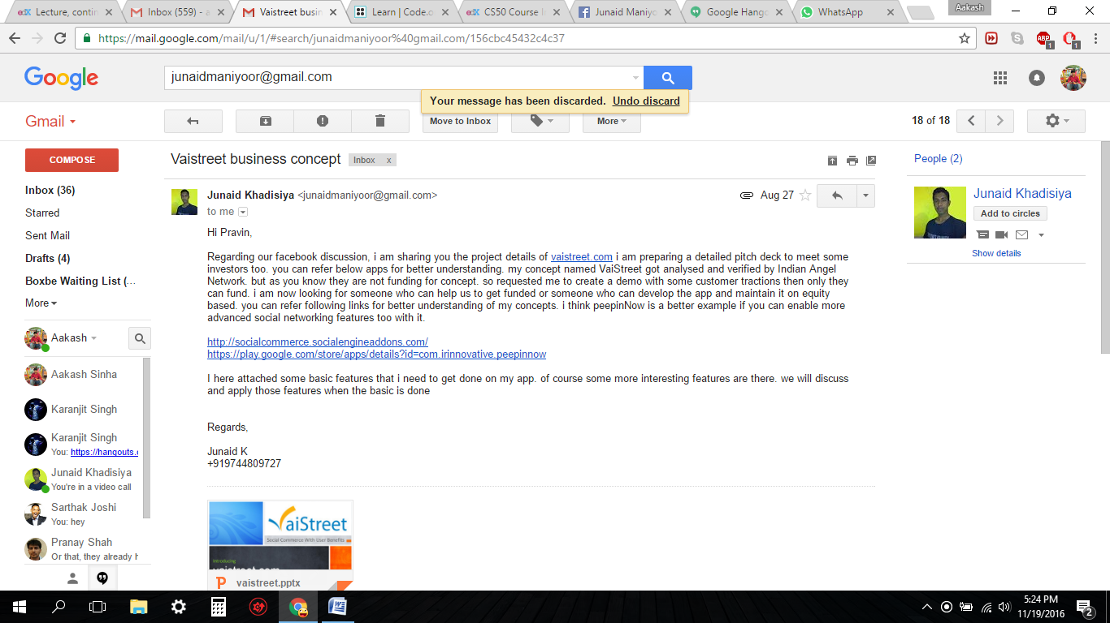

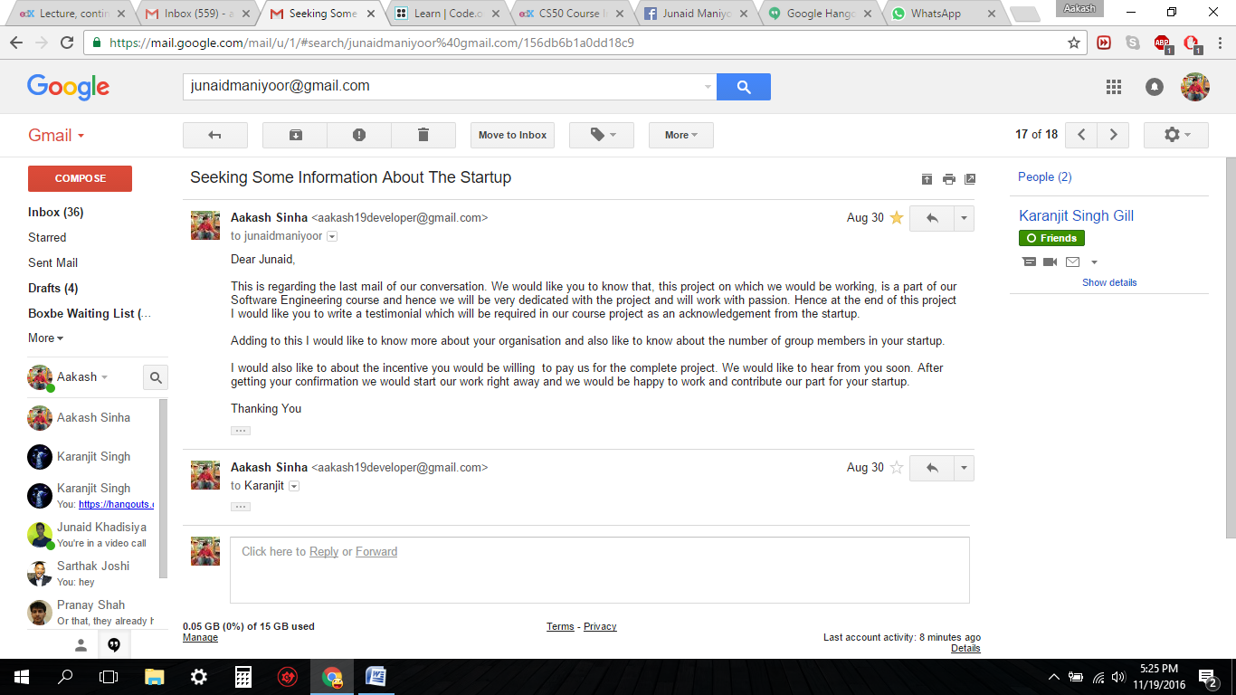

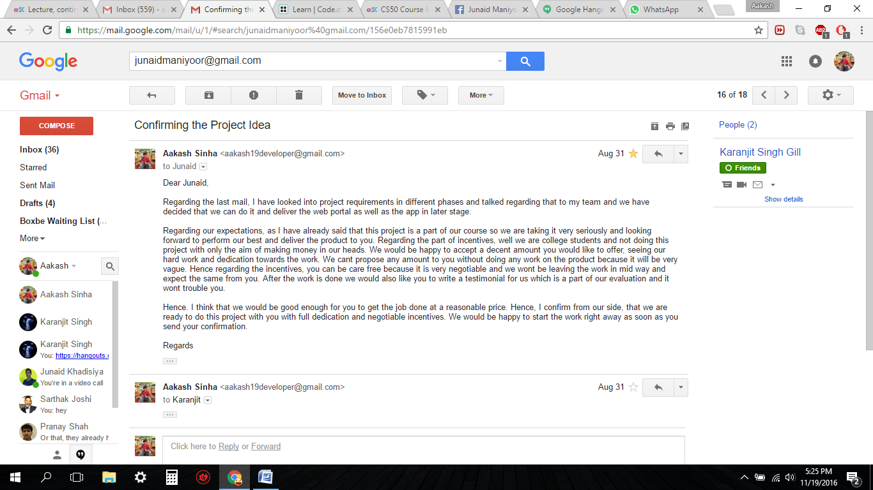

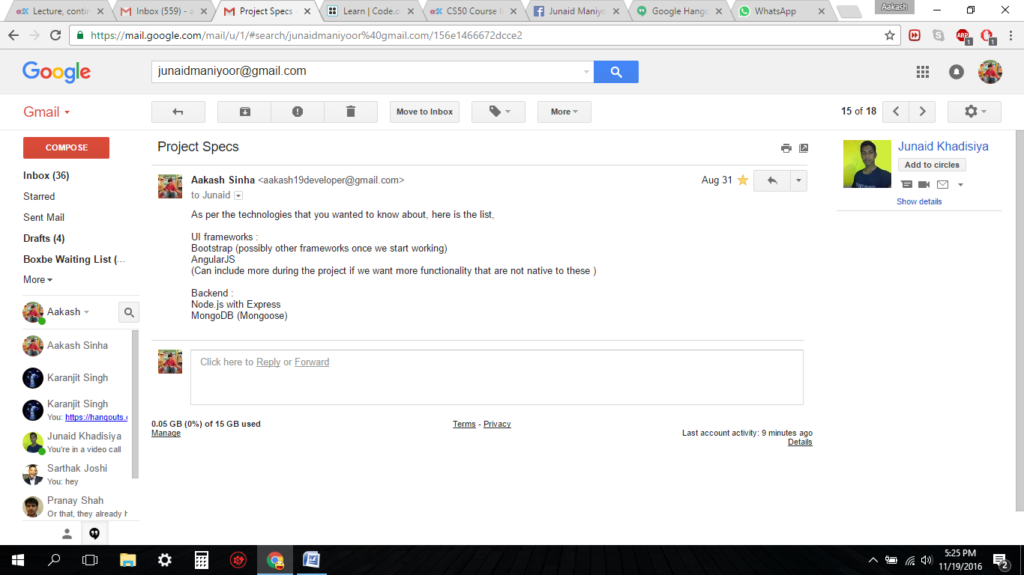

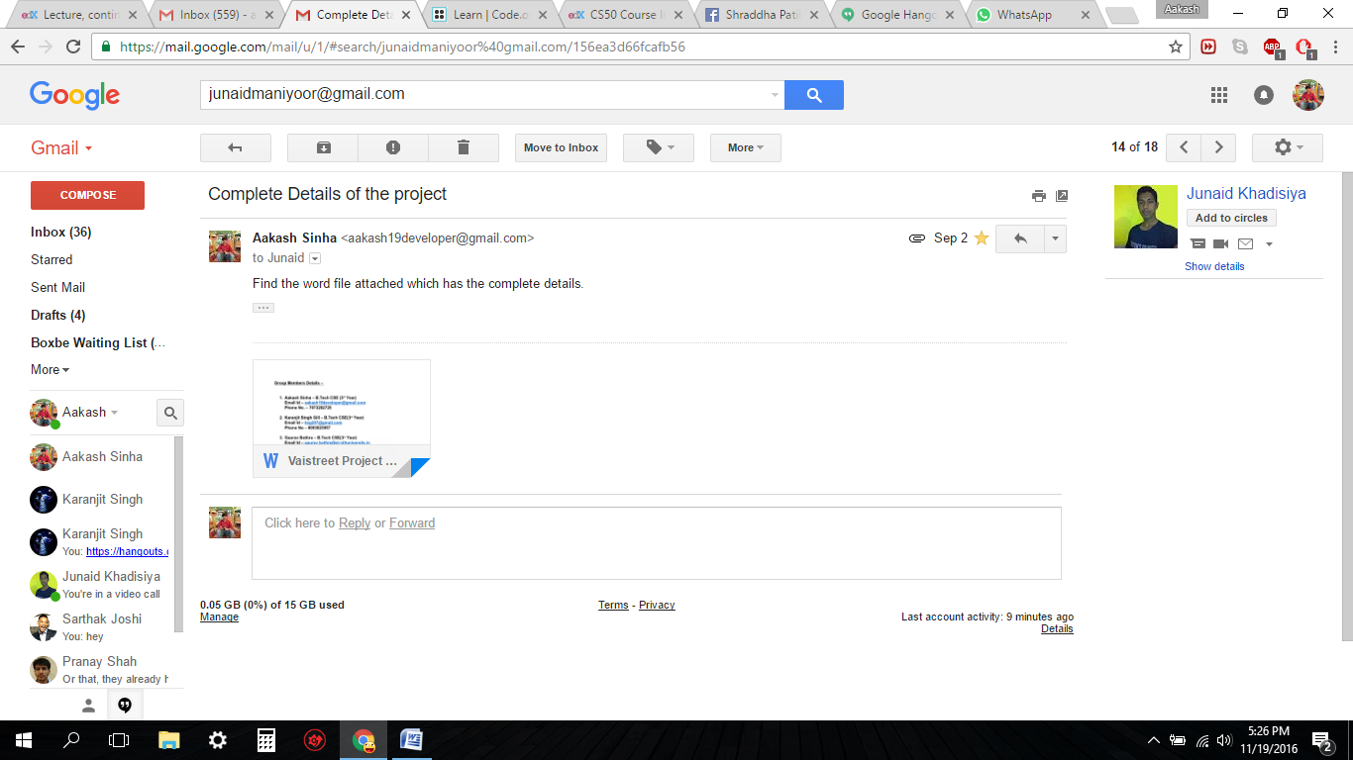

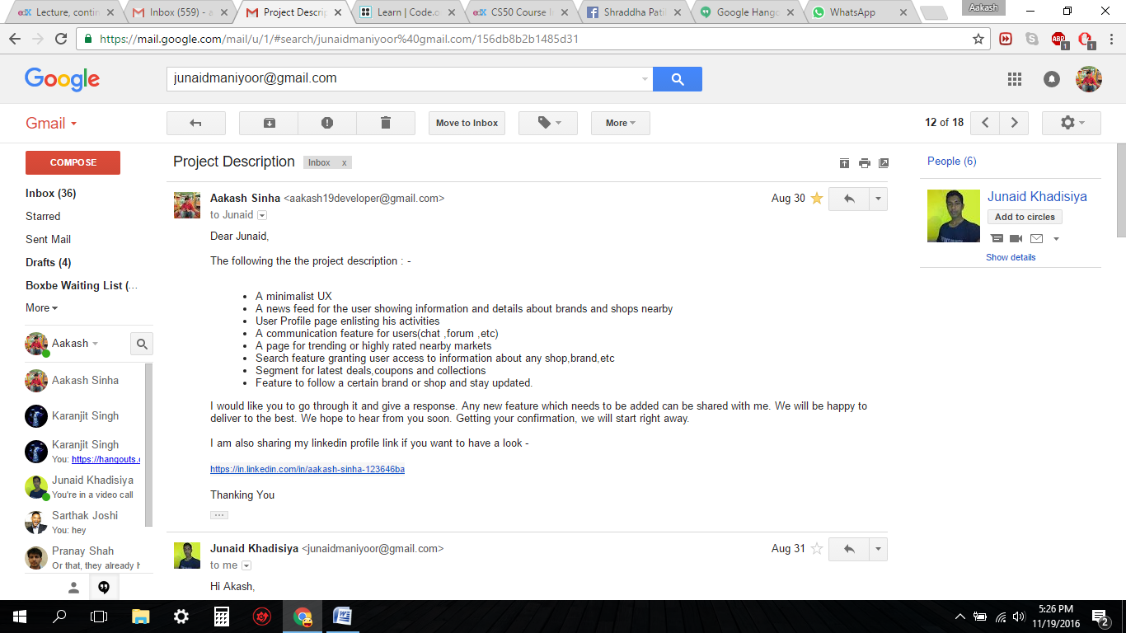

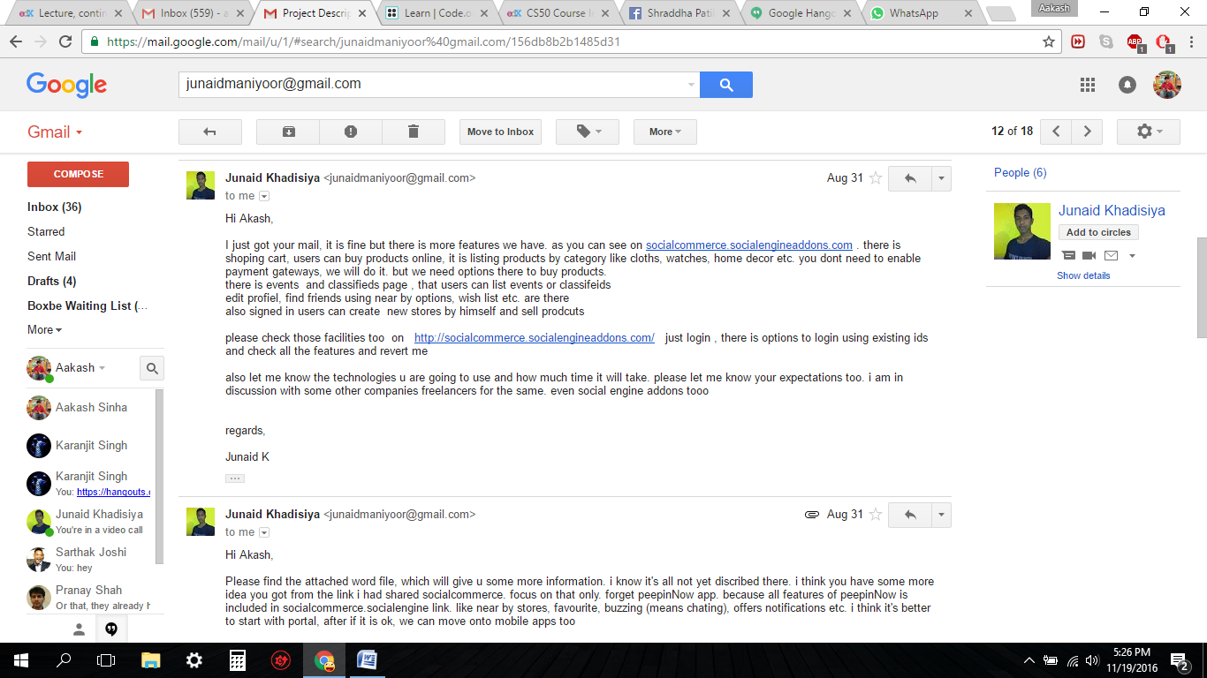

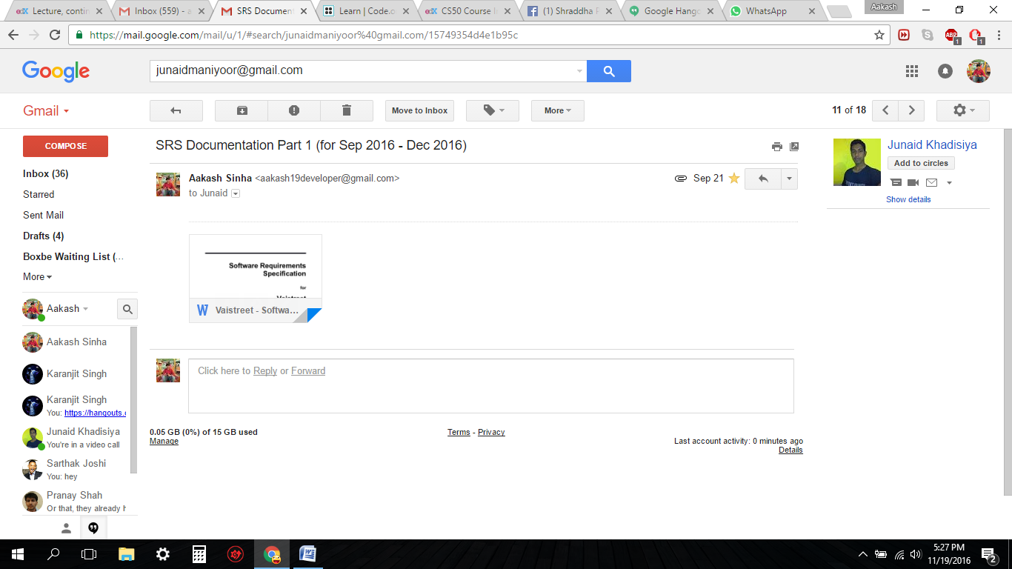

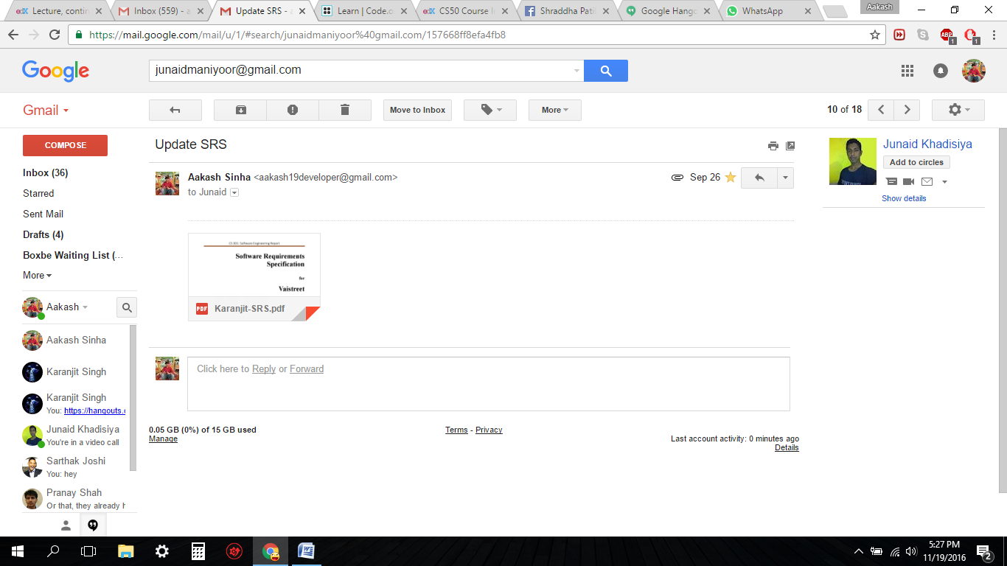

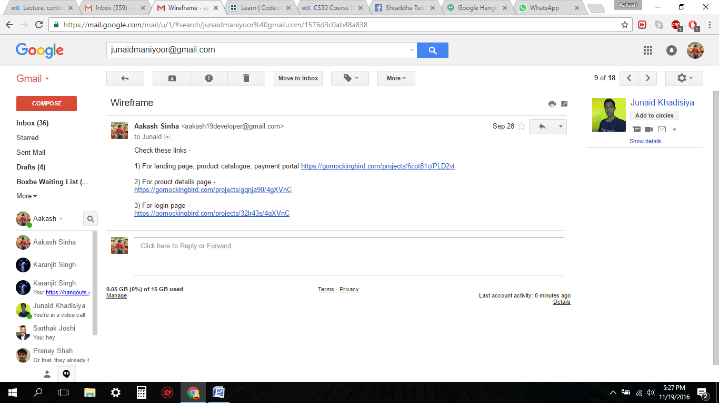

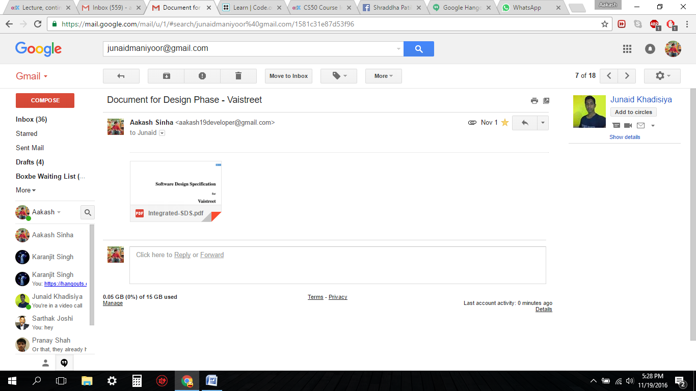

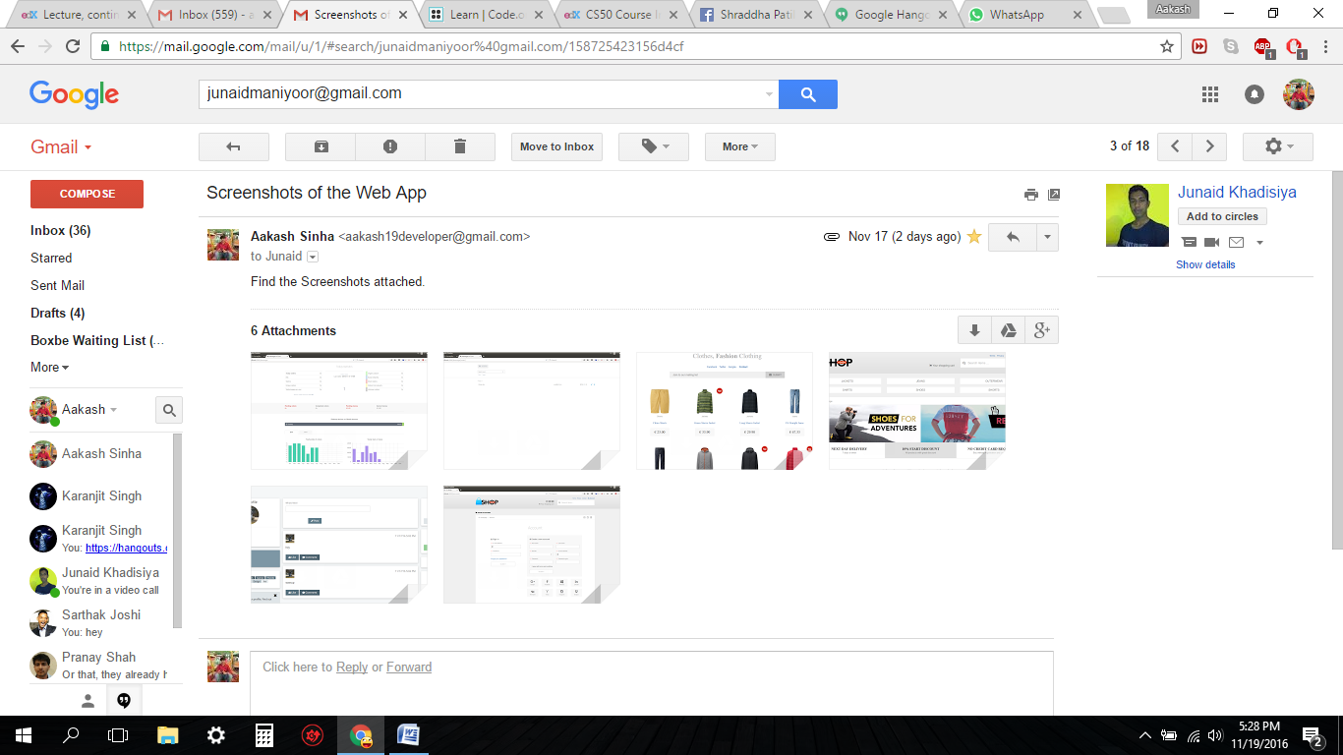

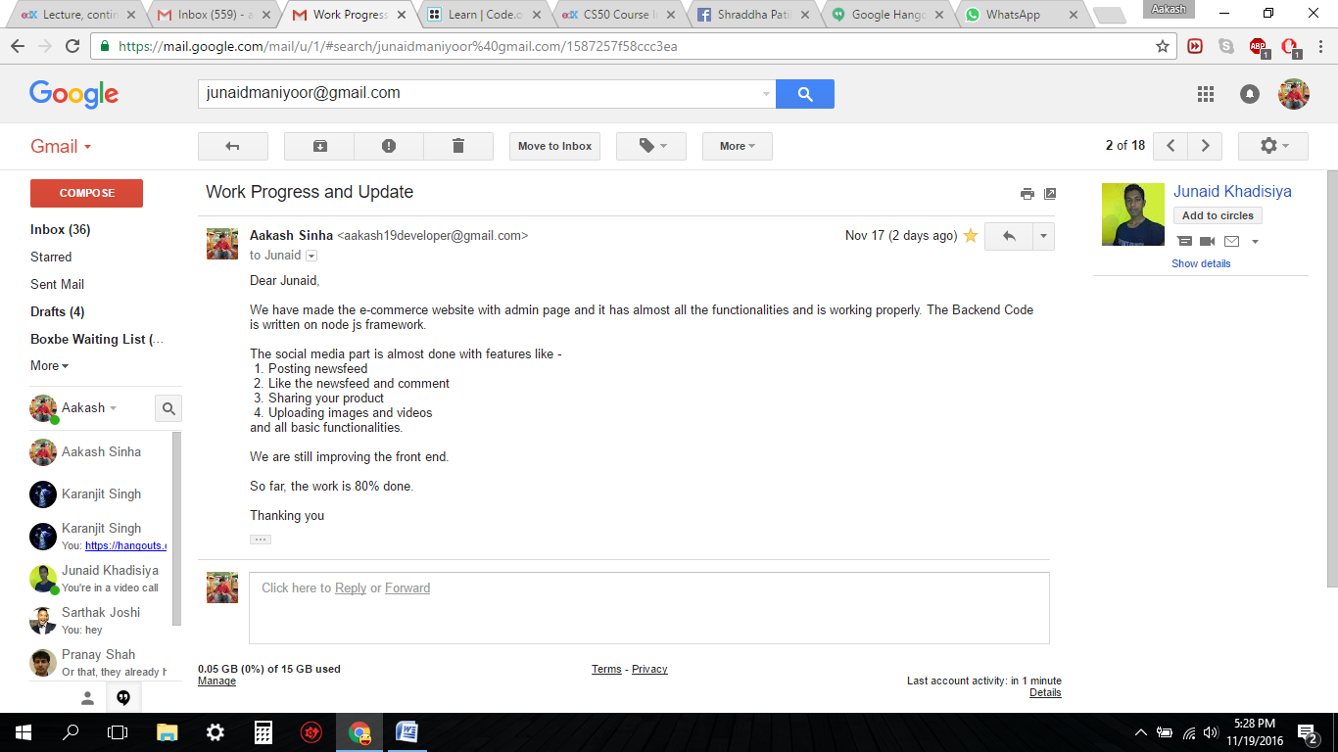

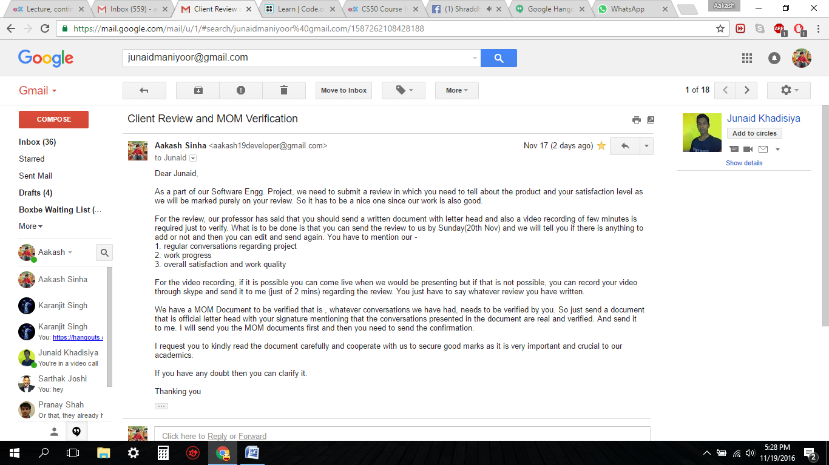

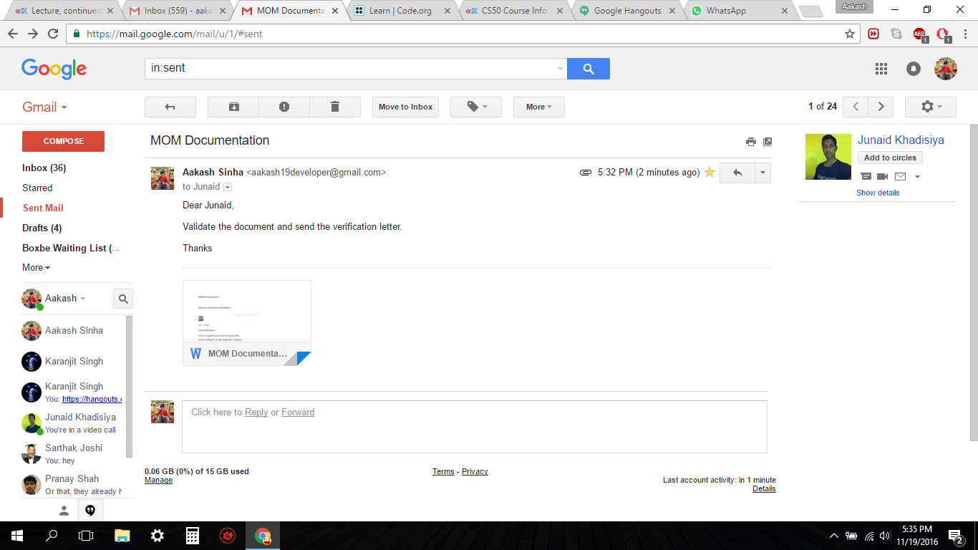

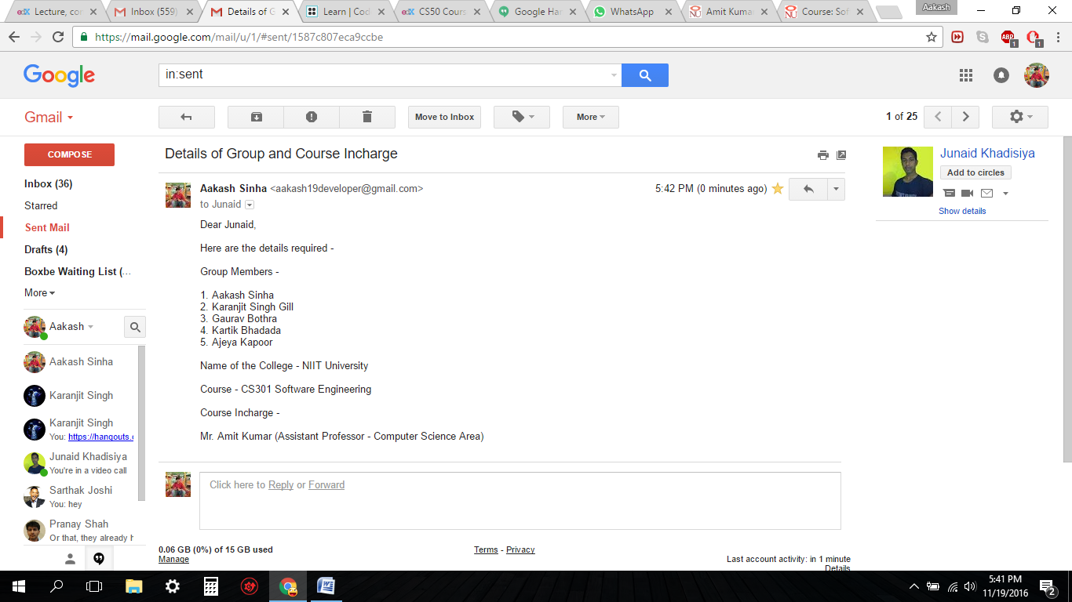

**4.** **Video Calls (Hangouts and Skype) –**

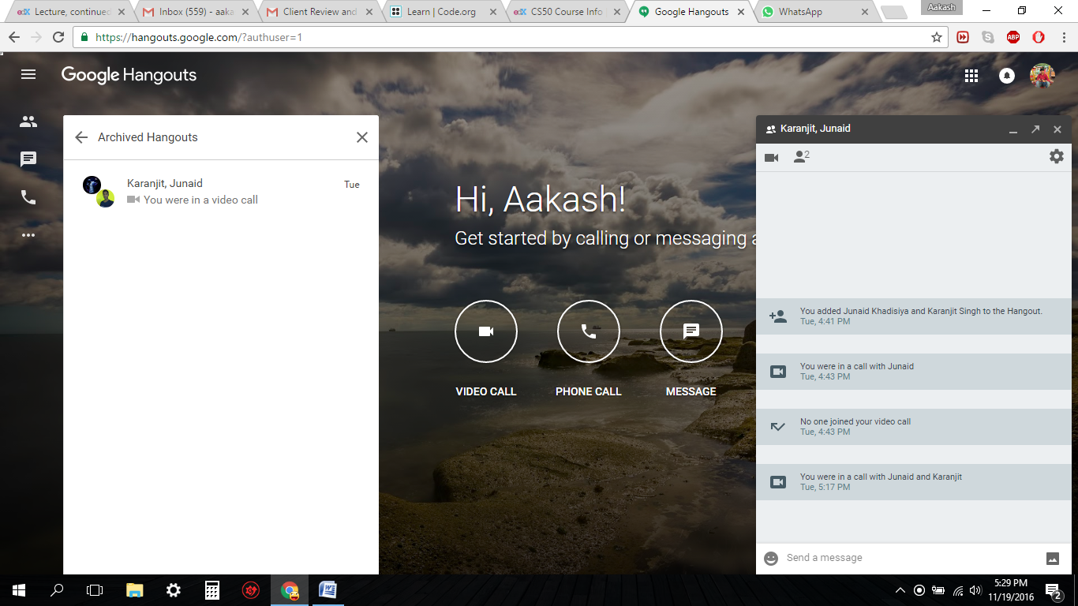

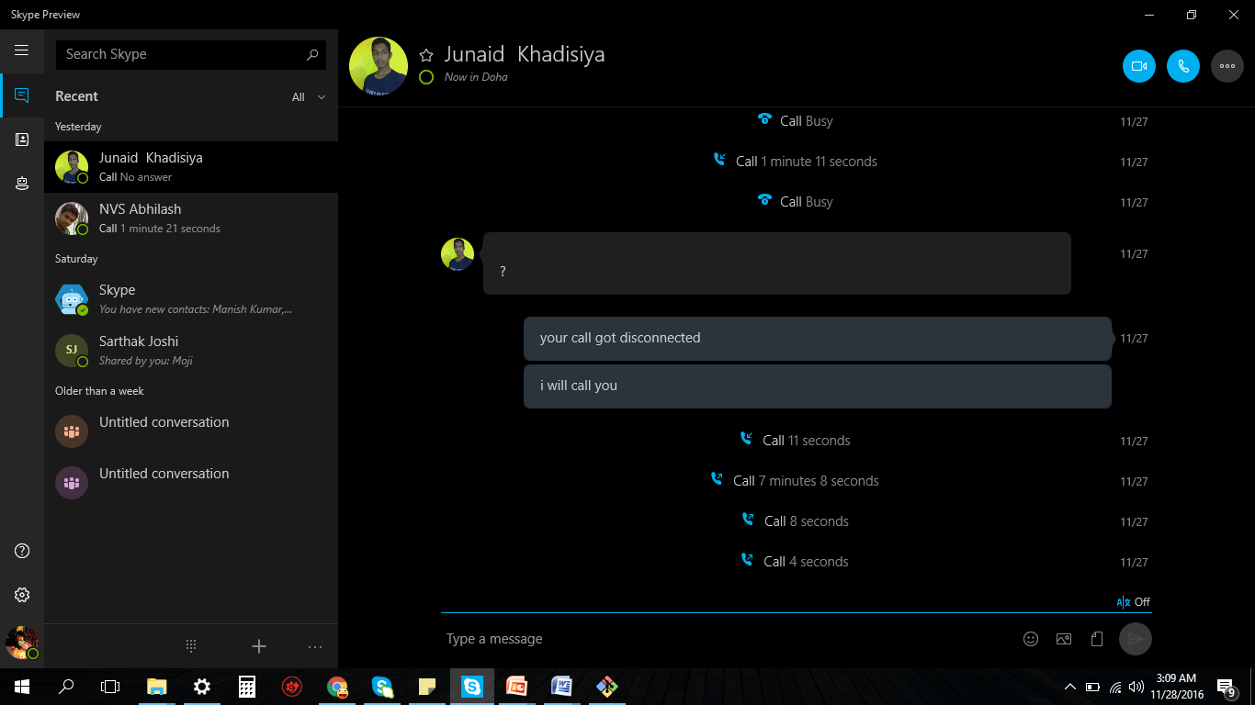

1. **Timeline Review**

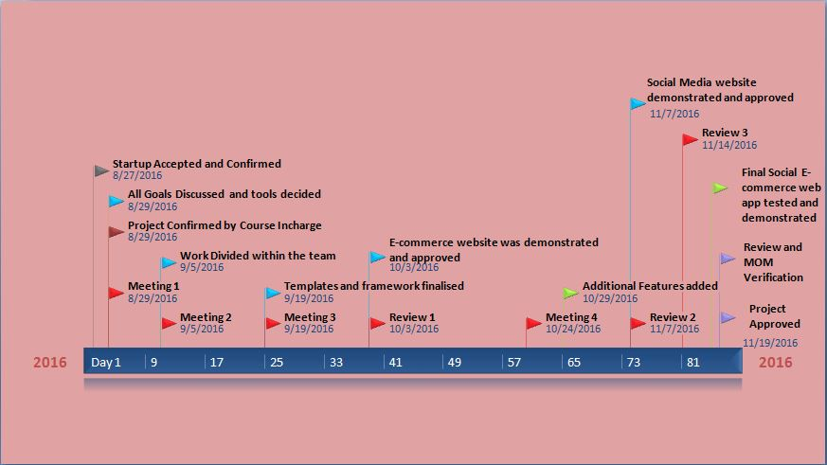

1. **Pie-Chart**
2. **Heartbeat**
3. **Weekly Analysis**

* **We have an estimated time of conversation per week–**

* **30 mins of Skype interaction**
* **1 hr of Facebook Interaction**
* **40 mins of Whatsapp interaction**
* **20 mins of Email interaction**